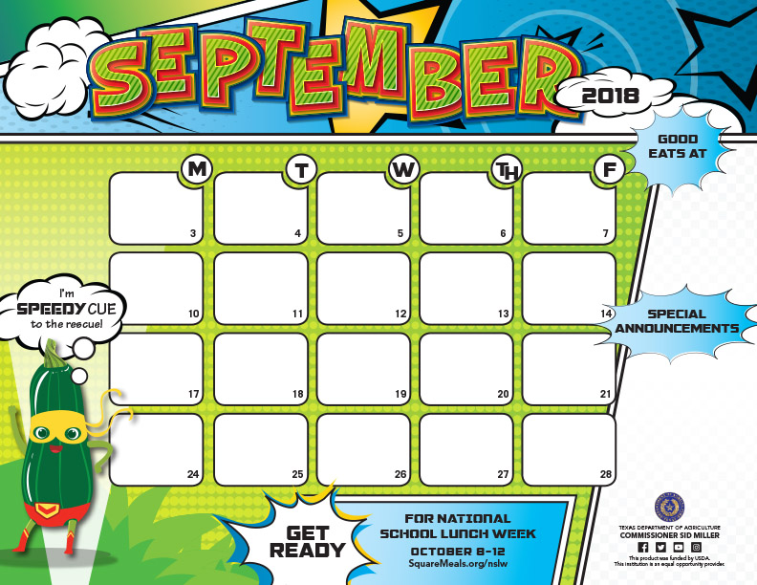

|  |
| --- |
| **GRANDPARENTS** |
| **BREAKFAST** |
| |  | | --- | | ***Bacon-n-Egg Biscuit*** | | **Assorted Cereals** | | **Buttered Toast** | | **Fresh Fruit Cup** | | **Assorted Juice** | | **Grape Jelly** | |
|  |
|  |
|  |
|  |

|  |
| --- |
| ***Sausage-n-Biscuit*** |
| **w/Jelly & Gravy** |
| **Assorted Cereals** |
| **Pop tart** |
| ***Orange Wedges*** |
| ***Assorted Juice*** |

|  |  |  |  |  |  |  |  |  |  |  |  |  |
| --- | --- | --- | --- | --- | --- | --- | --- | --- | --- | --- | --- | --- |
| |  |  |  |  |  |  |  | | --- | --- | --- | --- | --- | --- | --- | | |  | | --- | | ***Blueberry Pancakes*** | | **Syrup** | | **Assorted Cereals** | | **Yogurt** | | **Applesauce** | | ***Assorted Juice*** | | |  | |  | |  | |  | |  | |
|  |
|  |
|  |
|  |

|  |  |  |  |  |  |  |
| --- | --- | --- | --- | --- | --- | --- |
| |  | | --- | | **Kolache** | | **Assorted Cereals** | | **Cheese Toast** | | ***Mandarin Oranges*** | | ***Assorted Juice*** | |  | |
|  |
|  |
|  |
|  |
|  |

SCHOOL

HOLIDAY

**JOAQUIN ISD RAM CAFÉ Breakfast Menu**

**Elementary $1.75 Junior High $1.75 High School $1.75 Adult $2.25**

|  |
| --- |
| ***Cinnamon Roll*** |
| **Assorted Cereals** |
| **Cinnamon Toast** |
| **String Cheese** |
| **Applesauce Cup** |
| ***Assorted Juice*** |
|  |

|  |
| --- |
| ***Sausage-n-Biscuit*** |
| **w/Jelly & Gravy** |
| **Assorted Cereals** |
| **Pop tart** |
| ***Orange Wedges*** |
| ***Assorted Juice*** |

|  |  |  |  |  |  |  |  |
| --- | --- | --- | --- | --- | --- | --- | --- |
| |  | | --- | | ***Pancake on Stick*** | | **Syrup** | | **Assorted Cereals** | | **Yogurt** | | **Applesauce** | | ***Assorted Juice*** | |  | |
|  |
|  |
|  |
|  |

|  |  |  |  |  |  |  |
| --- | --- | --- | --- | --- | --- | --- |
| |  | | --- | | ***Scramble Egg*** | | **w/Bacon** | | **Assorted Cereals** | | **Cheese Toast** | | ***Mandarin Oranges*** | | ***Assorted Juice*** | |
|  |
|  |
|  |
|  |
|  |

|  |  |  |  |  |  |  |
| --- | --- | --- | --- | --- | --- | --- |
| |  | | --- | | **Chicken-n-Biscuit** | | **Assorted Cereals** | | **Buttered Toast** | | **Sliced Pears** | | **Assorted Juice** | | **Grape Jelly** | |
|  |
|  |
|  |
|  |
|  |

|  |
| --- |
| **Donut** |
| **Assorted Cereals** |
| **Cinnamon Toast** |
| **String Cheese** |
| **Applesauce Cup** |
| ***Assorted Juice*** |
|  |

|  |
| --- |
| ***Sausage-n-Biscuit*** |
| **w/Jelly & Gravy** |
| **Assorted Cereals** |
| **Pop tart** |
| ***Orange Wedges*** |
| ***Assorted Juice*** |

|  |
| --- |
| ***Mini Maple Waffle*** |
| **Syrup** |
| **Assorted Cereals** |
| **Yogurt** |
| **Applesauce** |
| ***Assorted Juice*** |

|  |
| --- |
| **Kolache** |
| **Assorted Cereals** |
| **Cheese Toast** |
| ***Mandarin Oranges*** |
| ***Assorted Juice*** |

|  |
| --- |
| ***Bacon-n-Egg Biscuit*** |
| **Assorted Cereals** |
| **Buttered Toast** |
| **Sliced Pears** |
| **Assorted Juice** |
| **Grape Jelly** |

Grandparents Breakfast

September 7, 2018

7:15 AM – 8:00AM

**Adult $2.25**

Choice of milk everyday: White 1% Low Fat or Flavored Fat Free.

Menus are subject tochange without notice.

|  |
| --- |
| ***Cinnamon Roll*** |
| **Assorted Cereals** |
| **Cinnamon Toast** |
| **String Cheese** |
| **Applesauce Cup** |
| ***Assorted Juice*** |
|  |

|  |
| --- |
| ***Sausage-n-Biscuit*** |
| **w/Jelly & Gravy** |
| **Assorted Cereals** |
| **Pop tart** |
| ***Orange Wedges*** |
| ***Assorted Juice*** |

|  |
| --- |
| **Breakfast Pizza** |
| **Assorted Cereals** |
| **Yogurt** |
| **Applesauce** |
| ***Assorted Juice*** |
|  |

|  |
| --- |
| ***Scramble Egg*** |
| **w/Bacon** |
| **Assorted Cereals** |
| **Cheese Toast** |
| ***Mandarin Oranges*** |
| ***Assorted Juice*** |

|  |
| --- |
| **Chicken-n-Biscuit** |
| **Assorted Cereals** |
| **Buttered Toast** |
| **Sliced Pears** |
| **Assorted Juice** |
| **Grape Jelly** |

