Contents

mental health matters

mental health and head start

Resilience

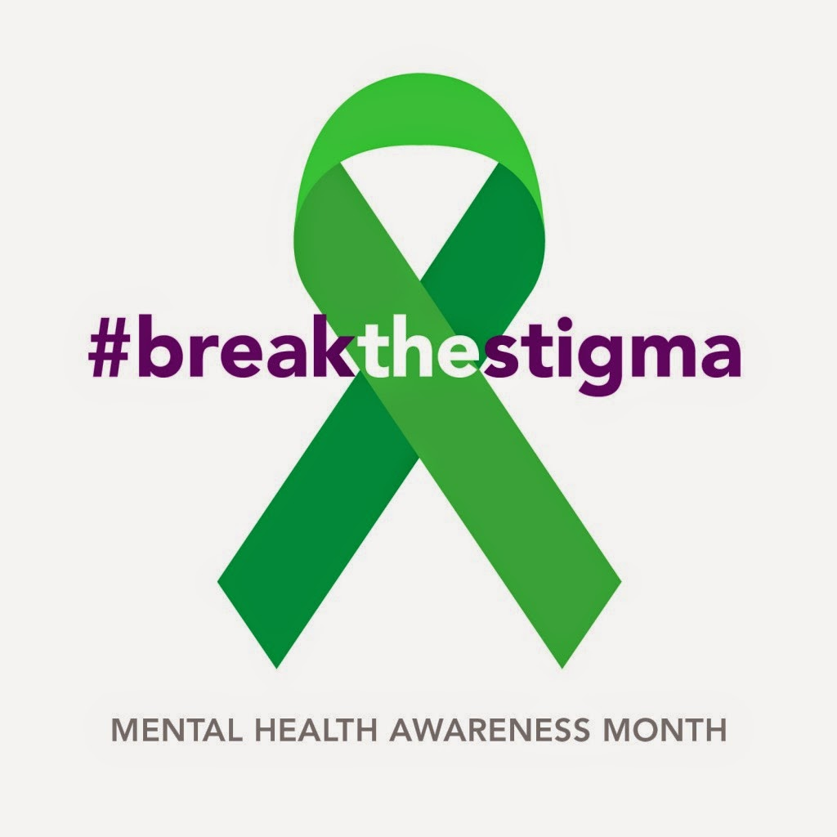

MENTAL HEALTH and HEAD START

Early childhood mental health is a child’s growing capacity to experience, regulate and express emotions. For children birth to 5 years of age, early childhood mental health is the same as social and emotional development. Head Start and Early Head Start have a long-standing partnership with mental health consultants and other community partners to promote the well-being of children, families and staff.

*May is National Children’s Mental Health Awareness Month. May 6-12, 2018 is Mental Health Awareness Week and May 10th is Children’s Mental Health Awareness Day.*

*Together we can end the stigma and build healthy communities that recognize the importance of children’s mental health.*

*Join us in raising awareness today.*

*During the week of May 6-12, 2018, please focus on children and youth who are at risk/or living with mental illness and let’s come together to advocate for a full array of effective services and supports for children affected by mental illness.*

*May 10, 2018, National Children’s Mental Health Awareness Day is designed to shine a spotlight on the importance of caring for every child’s mental health and reinforcing that positive mental health is essential to a child’s healthy development and well-being.*

## Teach Kindness and they will show Kindness

Advocate, Educate, Motivate

# Connections Newsletter

May, 2018 | Volume 1, Issue 3

## Mental health matters



CONNECTIONS NEWSLETTER

507 Crawford Center, Texas 75935

Phone – (936) 598-6315 Ext. 303

Fax – (936) 590-4002

vdavis@tccainc.org



### Connections Newsletter Page 2

You might know people who have faced great trials/trauma in their lives, but they continue to find success and happiness despite the odds against them. They have resilience, the ability to “**bounce** back” from misfortune or change. Resilient people tend to have something in their lives that helps them overcome challenges and move on in positive ways.

The impact Trauma has can be deep and life-shaping for people who have faced repeated and prolonged abuse and especially when violence is perpetrated by those who are supposed to be caretakers. Physical, sexual and emotional violence become central realities around which profound neurobiological and psychosocial adaptations occur. Survivors may come to see themselves as flawed and they may perceive the world as a pervasively dangerous place. Life trials and trauma can shape a person’s way of being and it can deflate the spirit and trample the soul.

We must work together to help families tap into their inner strengths which are called “protective factors”, in order to help children and their families cope with stressors and live successful lives.

“Practice feeling your feelings today, recognizing that feelings are like the weather. Some days are sunny, others are cloudy and some bring storms. Internal weather patterns come and go. – You are not bad if it rains today!” Easy to Love, Difficult to Discipline pg.175 Conscious Discipline

## What is resilience?

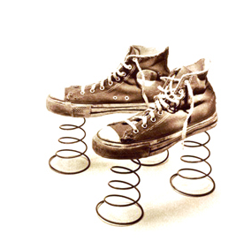

CHILDHOOD MENTAL HEALTH

Mental Health problems are common and can be serious, however they are treatable. Early diagnosis and treatment can prevent long-term problems.

Depression is - when a child feels sad or irritable for longer than (2) weeks.

Attention Deficit Hyperactivity Disorder (ADHHD)- is when a child experiences difficulty controlling actions, paying attention and being still.

Learning Disabilities - are when reading, math and /or writing of a child are below expected age, school and intelligence level. These children can become frustrated and discouraged, seeking attention through misbehavior and conduct problems.

Children naturally have frequent mood changes, but if any of the above symptoms occur over an extended period of time, talk to your mental health consultant, your pediatrician, local mental health authority or private counselor.

