2017
If you know of any child/children in Shelby County that may not have any Santa this Christmas, please fill out this form. One for each child and turn back into the Center Police Department Dispatch, ACE EMS, any Center ISD Campus front office, KQBB/Center Broadcasting, Light & Champion, Lasting Impressions, Mathews Real Estate or Shelby County Today. This form will need to be returned to the PD no later than the Monday before Christmas, 12/18/2017. Remember, all forms are anonymous.
Let Blue Santa help you make a Childs Christmas blessed this year.

CHILDS NAME:______________________________________________________________________ AGE:____SEX:____
PARENTS NAME:___________________________________PARENTS PHONE:___________________________________
DELIVERY ADDRESS:__________________________________________________________________________________
DIRECTIONS TO ADDRESS:_____________________________________________________________________________
__________________________________________________________________________________________________
__________________________________________________________________________________________________
DOES THE CHILD HAVE ANY SPECIAL NEEDS?:_____________________________________________________________
IF SO, PLEASE EXPLAIN:_______________________________________________________________________________
__________________________________________________________________________________________________

SOMETHING THE CHILD WANTS:________________________________________________________________________
SOMETHING THE CHILD NEEDS:________________________________________________________________________
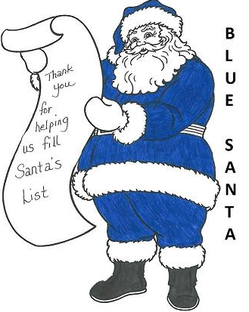
LIKES:_____________________________________________________________________________________
_____________________________________________________________________________
DISLIKES:______________________________________________________________________
READING/GRADE LEVEL:____________________ CLOTHING SIZE:________________________
HAVE YOU EVER RECEIVED BLUE SANTA BEFORE?______IF SO WHEN?____________________

