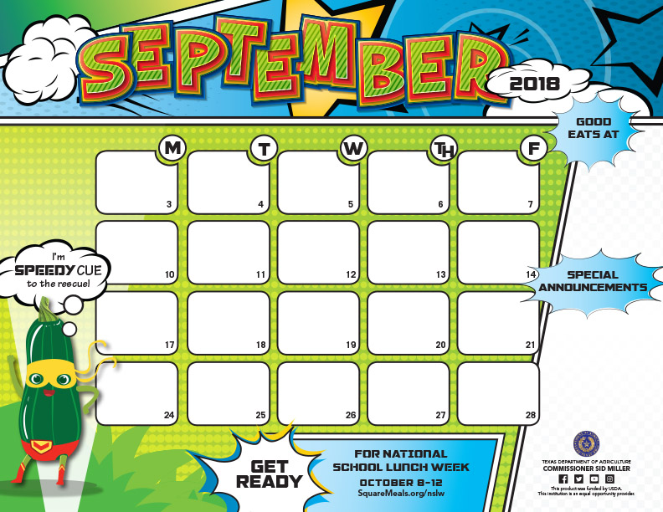

|  |
| --- |
| **Chef Salad** |
| **Steak Fingers** |
| ***Mashed Potatoes*** |
| **w/Gravy** |
| **Sweet Peas** |
| ***Whole Grain Roll*** |
| **Apple** |
| **Diced Peaches** |

|  |
| --- |
| **Chef Salad** |
| **Big Daddy's Pizza** |
| **Tacos** |
| **Sweet Corn** |
| **Chili Beans** |
| ***Salsa, Peppers*** |
| ***Orange Smile*** |
| ***Mixed Fruit*** |
| **Fruit Jell-O Cup** |

|  |
| --- |
| **Chicken or Hamburger** |
| **on Bun** |
| **Sliced Cheese** |
| **Fries** |
| **Broccoli w/Sauce** |
| **Burger Veggies** |
| **Applesauce Cup** |
| **Sidekick Fruit Slush** |
|  |

|  |
| --- |
| **Chef Salad** |
| **Big Daddy's Pizza** |
| ***Nachos w/Cheese Sauce*** |
| **Buttered Corn** |
| **Pinto Beans** |
| ***Salsa, Peppers*** |
| ***Orange Wedges*** |
| **Mango Chunks** |
| **Chocolate Pudding** |

|  |
| --- |
| **Chef Salad** |
| ***Chicken Chunk*** |
| ***Mashed Potatoes*** |
| **w/Gravy** |
| **Mix Vegetables** |
| ***Whole Grain Roll*** |
| ***Sliced Peach Cup*** |
| **Apple** |

|  |
| --- |
| **Chef Salad** |
| **Big Daddy's Pizza** |
| **Beef Burrito w/Queso** |
| **Sweet Corn** |
| **Chili Beans** |
| ***Salsa, Peppers*** |
| ***Orange Smile*** |
| ***Mixed Fruit*** |
| **Fruit Jell-O Cup** |

|  |
| --- |
| **Chef Salad** |
| ***Chicken Tenders*** |
| ***Mashed Potatoes*** |
| **w/Gravy** |
| **Sweet Peas** |
| ***Whole Grain Roll*** |
| **Apple** |
| **Diced Peaches** |

|  |
| --- |
| **Chef Salad** |
| **Big Daddy's Pizza** |
| **Asian Glazed Chicken** |
| **Fried Rice** |
| **Buttered Corn** |
| **Pinto Beans** |
| ***Orange Wedges*** |
| **Mango Chunks** |
| **Fortune Cookie** |

|  |
| --- |
| **Chef Salad** |
| **Hoagie Melt Basket** |
| ***Stuffed Crust Pizza*** |
| ***Green Beans*** |
| **Veggie Bar** |
| **w/Ranch Dressing** |
| **Strawberries** |
| **Sliced Pears** |

SCHOOL

HOLIDAY

|  |
| --- |
| **Chef Salad** |
| **Chicken Burger Basket** |
| **French Bread Pizza** |
| ***Green Beans*** |
| **Veggie Bar** |
| **w/Ranch Dressing** |
| **Strawberries** |
| **Pineapple Tidbits** |

|  |
| --- |
| **Chef Salad** |
| **Hoagie Melt Basket** |
| ***Stuffed Crust Pizza*** |
| ***Green Beans*** |
| **Veggie Bar** |
| **w/Ranch Dressing** |
| **Strawberries** |
| **Sliced Pears** |

**JOAQUIN ISD RAM CAFÉ Lunch Menu**

**Elementary $2.50**

**Junior High $2.50**

**High School $2.75**

**Adult $3.50**

|  |
| --- |
| **Chef Salad** |
| **BBQ Sandwich** |
| **Baked Potato w/Cheese** |
| **Glazed Carrots** |
| **Veggie Bar** |
| **w/Ranch Dressing** |
| ***Grapes*** |
| ***Mandarin Oranges*** |

|  |
| --- |
| **Chef Salad** |
| **Chicken Burger Basket** |
| **French Bread Pizza** |
| ***Green Beans*** |
| **Veggie Bar** |
| **w/Ranch Dressing** |
| **Strawberries** |
| **Pineapple Tidbits** |

|  |
| --- |
| **Chicken or Hamburger** |
| **on Bun** |
| **Sliced Cheese** |
| **Fries** |
| **Cauliflower w/Sauce** |
| **Burger Veggies** |
| **Applesauce Cup** |
| **Fruit Slush** |
|  |

|  |
| --- |
| **Chef Salad** |
| **Boneless Chicken Wing** |
| ***Mashed Potatoes*** |
| **w/Gravy** |
| **Mix Vegetables** |
| ***Whole Grain Roll*** |
| ***Sliced Peach Cup*** |
| **Apple** |

|  |
| --- |
| **Chef Salad** |
| **Corn Dog** |
| **Macaroni & Cheese** |
| **Baked Beans** |
| **Sweet Potatoes** |
| **Veggie Bar w/ Dressing** |
| ***Grapes*** |
| ***Mandarin Oranges*** |
|  |

|  |
| --- |
| **Chicken or Hamburger** |
| **on Bun** |
| **Sliced Cheese** |
| **Fries** |
| **Broccoli w/Sauce** |
| **Burger Veggies** |
| **Applesauce Cup** |
| **Fruit Slush** |
|  |

**Snack Bar Drinks $1.00 Chips $1.00 Cookies $ .50 Ice Cream $1.00 Rice Krispies Treat $1.00 Dipping Dots $2.50 Entrée $2.00 Side Dishes $1.00 Must have cash for snack bar. No Charging Snacks.**

**Choice of milk everyday: White 1% Low Fat or Flavored Fat Free. Menus are subject to change without notice.**

|  |
| --- |
| **Chef Salad** |
| **Chicken Spaghetti** |
| **Baby Lima Beans** |
| **Glazed Carrots** |
| **Veggie Bar/ Dressing** |
| **Garlic Toast** |
| ***Grapes*** |
| ***Mandarin Oranges*** |
|  |

|  |
| --- |
| **Chicken or Hamburger** |
| **on Bun** |
| **Cheese Slice** |
| **Fries** |
| **Cauliflower w/Sauce** |
| **Burger Veggies** |
| **Applesauce Cup** |
| **Fruit Slush** |
|  |

