Tenaha ISD Students of the Month
Each month teachers nominate students that exhibit outstanding qualities in and out of the classroom. Students that are featured each month display leadership skills, inspires others to excel and are committed to promoting a positive attitude towards achieving their goals.
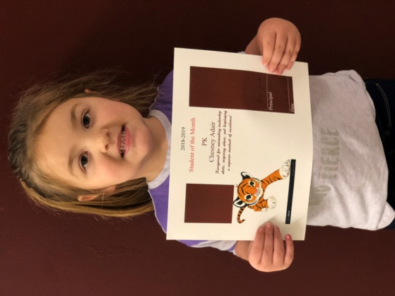
Chesney Adair-PK
Chesney is the daughter of Mianna and Casey Adair. Her favorite activity at school is playing in Learning Centers. She is a great listener in the classroom. Chesney enjoys cheerleading, dance and helping others.
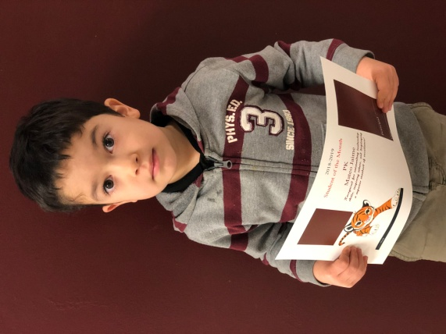
Mateo Jaime-PK
Mateo is the son of Sara and Cesar Jaime. He loves learning about everything! He is very good at helping others. Mateo enjoys running, playing soccer and painting projects.
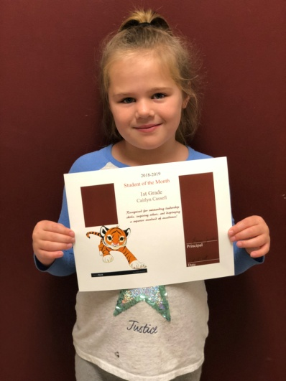
Caitlyn Cassell-1st Grade
Caitlyn is the daughter of Brooke and Michael Cassell. Her favorite subjects are reading and math. Caitlyn is a great student that makes wise choices and always willing to lend a helping hand. She is a good friend to others. She enjoys playing with her friends and working on the IPad.
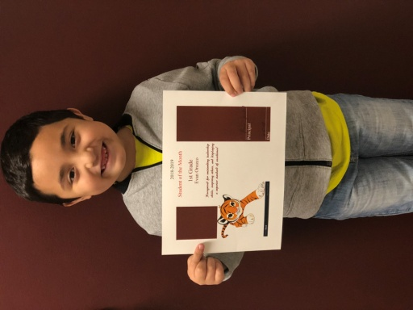
Evan Orozco-1st Grade
Even is the son of Liliana and Eveiz Orozco. His favorite subject is math because he likes numbers! He is a fantastic reader and is always on task. He is a great help to others, makes good choices, and is fun to be around. Evan loves being the Math leader and playing with his friends.
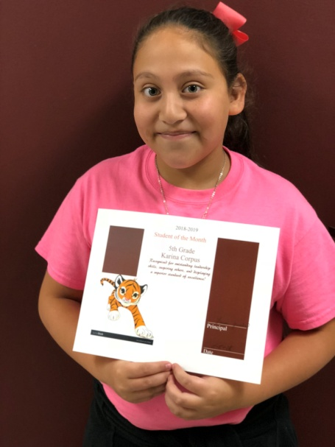
Karina Corpus-5th Grade
Karina is the daughter of Jose’ and Veronica Corpus. Her favorite subject is Band! Karina is a hard worker. She gets along very well with others and is always willing to help anyone out when asked. She is an outstanding student with a great personality. She enjoys watching TV and playing outside.
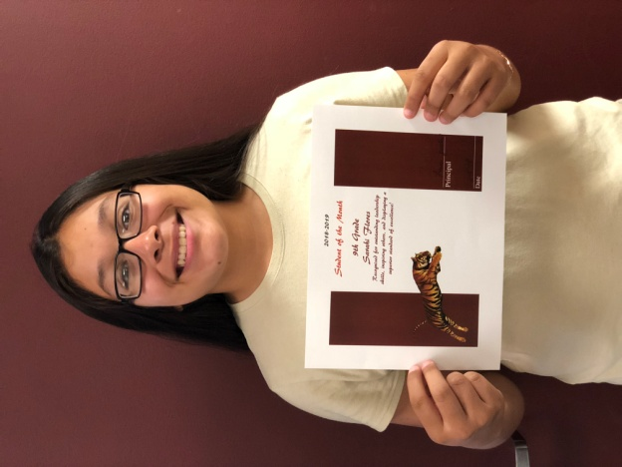
Sarahi Flores-9th Grade
Sarahi is the daughter of Angelina and Elrsea Flores. Her favorite subject is Geometry. Sarahi is an active member of the JCCs, BETA club and the Roarin’ Band from Tigerland. She is a member of the soccer team, cross country and plans to join the softball team. She plans to attend Stephen F. Austin State University after high school graduation.
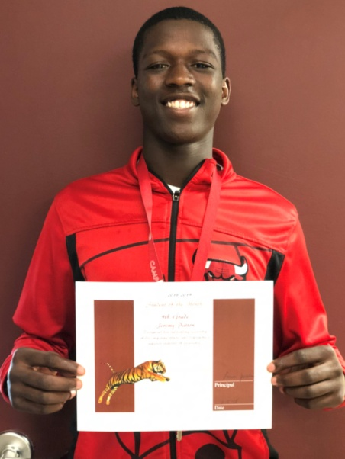
Jeremy Patton-9th Grade
Jeremy is the son of Kristy Norris. His favorite subject is English. Jeremy is a member of the Tiger football, track and basketball teams. His passion is football! His goal after high school is to one day attend University of Alabama and play football. He is hopeful that after college he will be drafted to play professional football.

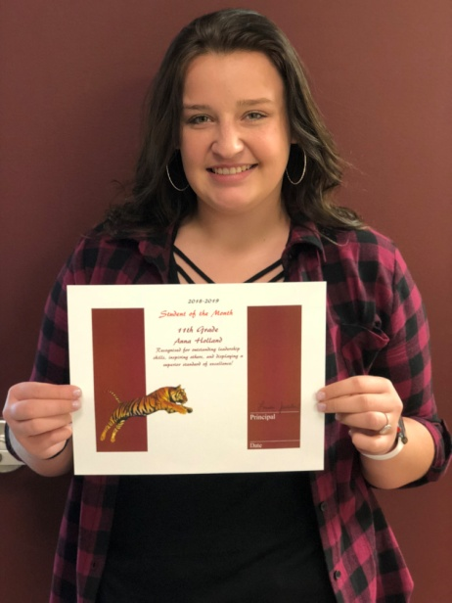

Anna Holland-11th Grade
Anna Holland is the daughter of Pamela Hicks and Leslie Hicks, and the late Jim Holland. Her favorite subject is Math. Anna participates in the Tenaha FFA and plays Lady Tiger basketball. Anna plans to attend a college of her choice after high school and become a veterinarian.

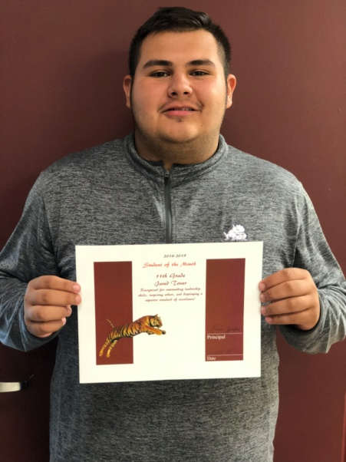
Jared Tovar-11th Grade
Jared is the son of Erika and Guadalupe Tovar. His favorite subject is Math. Jared is an active member of the BETA club and the Roarin’ Band from Tigerland. He plays football and basketball. His plans after graduating high school are to attend a 4 year university and earn a degree in accounting.

