

If you know of any child (Infant – 15yrs) in **Shelby County** that may not have any Santa this Christmas, please fill out this form. **One for each child and turn back into the Center Police Department Dispatch**, **or Shelby County Today**. This form will need to be returned to the PD no later than **Monday, Dec 9th, 2019**. Any form turned in after the due date will **NOT** be accepted. This ensures us plenty of time to get all the toys we will need.

Remember, all forms are anonymous.

Let Blue Santa help you make a Childs Christmas blessed this year.

**Forms or monetary donations can be mailed to P.O. Box 322 Center, Tx 75935**

2019

CHILDS NAME:______________________________________________________________________ AGE:____SEX:____

PARENTS NAME:___________________________________PARENTS PHONE:___________________________________

DELIVERY ADDRESS:__________________________________________________________________________________

DIRECTIONS TO ADDRESS:_____________________________________________________________________________

__________________________________________________________________________________________________

__________________________________________________________________________________________________

DOES THE CHILD HAVE ANY SPECIAL NEEDS?:_____________________________________________________________

IF SO, PLEASE EXPLAIN:_______________________________________________________________________________

__________________________________________________________________________________________________

SOMETHING THE CHILD WANTS:________________________________________________________________________

SOMETHING THE CHILD **NEEDS**:________________________________­________________________________________

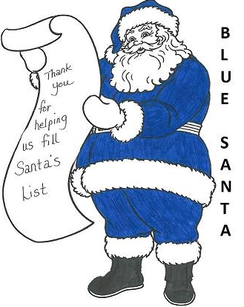LIKES:_____________________________________________________________________________________

_____________________________________________________________________________

DISLIKES:______________________________________________________________________

READING/GRADE LEVEL:____________________ CLOTHING SIZE:________________________

HAVE YOU EVER RECEIVED BLUE SANTA BEFORE?______IF SO WHEN?____________________