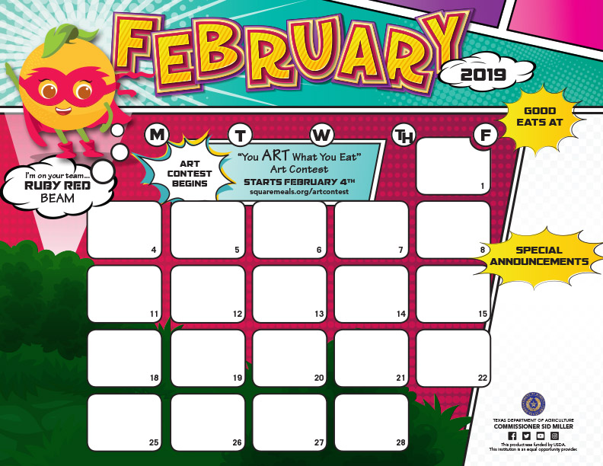

|  |  |  |  |  |  |  |  |  |
| --- | --- | --- | --- | --- | --- | --- | --- | --- |
| |  | | --- | | **Chicken or Hamburger** | | **on Bun** | | **Cheese Slice** | | **Fries** | | **Mix Vegetable Salad** | | **Burger Veggies** | | **Sliced Pears Cup** | | **Strawberry Fruit Slush** | |
|  |
|  |
|  |
|  |
|  |
|  |
|  |

SCHOOL HOLIDAY

|  |
| --- |
| **Chicken Rings** |
| ***Mashed Potatoes*** |
| **w/Gravy** |
| **Roasted Broccoli** |
| ***Whole Grain Roll*** |
| **Frosty Peach Cup** |
| **Diced Pears** |

**JOAQUIN ISD RAM CAFÉ Lunch Menu**

**Elementary $2.50**

**Junior High $2.50**

**High School $2.75**

**Adult $3.50**

|  |  |  |  |  |  |  |  |  |  |  |  |  |  |  |  |  |  |  |  |  |  |
| --- | --- | --- | --- | --- | --- | --- | --- | --- | --- | --- | --- | --- | --- | --- | --- | --- | --- | --- | --- | --- | --- |
| |  |  |  |  |  |  |  |  |  |  |  |  |  |  |  | | --- | --- | --- | --- | --- | --- | --- | --- | --- | --- | --- | --- | --- | --- | --- | | |  | | --- | |  | | |  | | --- | |  | | **Chef Salad** | | ***Stuffed Crust Pizza*** | | ***Green Beans*** | | **Healthy Salad w/Dressing** | | **Icee Strawberries Cup** | | **Apple Slices** | | |  | |  | |  | |  | |  | | |  | |  | |  | |  | |  | |  | |
|  |
|  |
|  |
|  |
|  |
|  |

|  |
| --- |
|  |
| **Big Daddy's Pizza** |
| **Asian Glazed Chicken** |
| **Fried Rice & Fortune Cookie** |
| **Buttered Corn** |
| **Veggie Bar w/Dressing** |
| **Orange Smiles** |
| **Pineapple Tidbit** |

|  |
| --- |
| **Steak Fingers** |
| ***Mashed Potatoes*** |
| **w/Gravy** |
| **Mix Vegetables** |
| ***Whole Grain Roll*** |
| **Frosty Peach Cup** |
| **Sliced Blushing Pears** |

|  |
| --- |
| **Chicken or Hamburger** |
| **w/Bacon on Bun** |
| **Sliced Cheese** |
| **Fries** |
| **Cauliflower w/Sauce** |
| **Burger Veggies** |
| **Diced Pears Cup** |
| **Strawberry Fruit Slush** |

|  |
| --- |
| ***Chicken Chunks*** |
| **Lima Beans** |
| **Sweet Glazed Carrots** |
| **Corn Bread** |
| **Veggie Bar w/Dressing** |
| ***Mixed Fruit*** |
| ***Mandarin Oranges*** |

|  |
| --- |
|  |
| **Chef Salad** |
| **French Bread Pizza** |
| ***Green Beans*** |
| **Healthy Salad w/Dressing** |
| **Icee Strawberries Cup** |
| **Cantaloupe Chunks** |

|  |
| --- |
| **Chicken or Hamburger** |
| **on Bun** |
| **Cheese Slice** |
| **Fries** |
| **Green Pea Salad** |
| **Burger Veggies** |
| **Sliced Pears Cup** |
| **Cherry Fruit Slush** |

|  |
| --- |
| **Valentine Day** |
| **Chicken & Dumplings** |
| **Seasoned Green Beans** |
| **Veggie Bar** |
| ***Hot Wheat Roll*** |
| **Orange Smiles** |
| **Grapefruit Wedges** |
| **Strawberry Sundae** |

|  |  |  |  |  |  |  |  |
| --- | --- | --- | --- | --- | --- | --- | --- |
| |  | | --- | | **Chicken Bites** | | **Bake Potato Soup** | | **Ranch Beans** | | **Cinnamon Sweet Potatoes** | | **Veggie Bar w/Dressing** | | ***Mixed Grapes*** | | ***Fruit Bowl*** | |
|  |
|  |
|  |
|  |
|  |
|  |

**Snack Bar Drinks $1.00 Chips $1.00 Cookies $ .50 Ice Cream $1.00 Rice Krispies Treat $1.00 Entrée $2.00 Side Dishes $1.00**

**Must have cash for snack bar. No Charging Snacks.**

**Choice of milk everyday: White 1% Low Fat or Flavored Fat Free. Menus are subject to change without notice.**

|  |  |  |  |  |  |  |  |
| --- | --- | --- | --- | --- | --- | --- | --- |
| |  | | --- | |  | | **Chef Salad** | | ***Stuffed Crust Pizza*** | | ***Green Beans*** | | **Healthy Salad w/Dressing** | | **Icee Strawberries Cup** | | **Honeydew Chunks** | |
|  |
|  |
|  |
|  |
|  |
|  |

|  |
| --- |
| **Salisbury Steak** |
| ***Mashed Potatoes*** |
| **w/Gravy** |
| **Sweet Peas** |
| ***Whole Grain Roll*** |
| **Frosty Peach Cup** |
| **Diced Pears w/Cherry top** |

|  |
| --- |
|  |
| **Big Daddy's Pizza** |
| **Crispy Tacos w/Salsa** |
| **Sweet Corn** |
| **Spanish Rice** |
| **Veggie Bar w/Dressing** |
| **Orange Smiles** |
| **Mango Chunks** |

|  |
| --- |
| **Chicken or Hamburger** |
| **w/Bacon on Bun** |
| **Sliced Cheese** |
| **Fries** |
| **Mix Vegetable Salad** |
| **Burger Veggies** |
| **Diced Pears Cup** |
| **Strawberry Fruit Slush** |

|  |
| --- |
| **Chicken Spaghetti** |
| **Black-Eyed Pea** |
| **Cinnamon Sweet Potatoes** |
| **Veggie Bar w/Dressing** |
| **Corn Bread** |
| ***Mixed Fruit*** |
| ***Mandarin Oranges*** |

|  |
| --- |
| **Boneless Chicken Wing** |
| ***Mashed Potatoes*** |
| **w/Gravy** |
| **Mix Vegetables** |
| ***Whole Grain Roll*** |
| **Frosty Peach Cup** |

**Sliced Blushing Pears**

|  |
| --- |
|  |
| **Big Daddy's Pizza** |
| **Asian Glazed Chicken** |
| **Fried Rice & Fortune Cookie** |
| **Buttered Corn** |
| **Veggie Bar w/Dressing** |
| **Orange Wedges** |
| **Pineapple Tidbit** |
|  |
|  |

|  |
| --- |
|  |
| **Chef Salad** |
| **French Bread Pizza** |
| ***Green Beans*** |
| **Healthy Salad w/Dressing** |
| **Icee Strawberries Cup** |
| **Apple Slices** |

