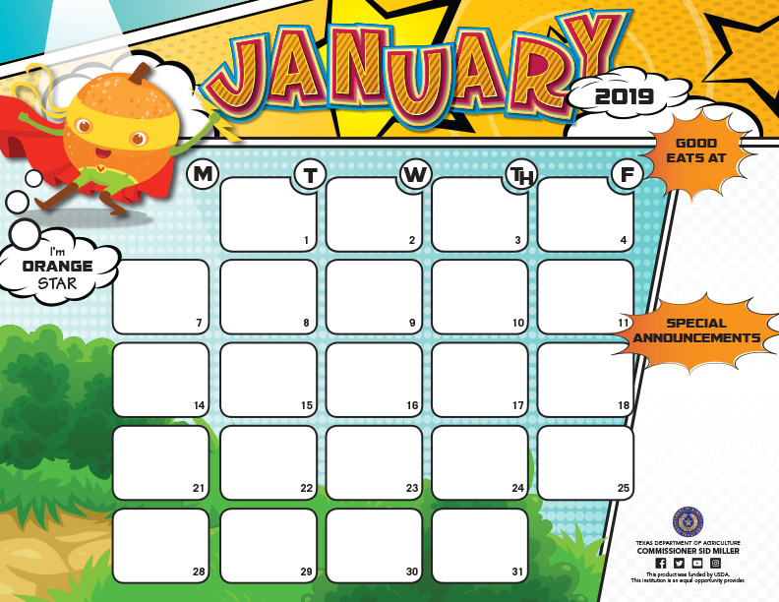

SCHOOL HOLIDAY

SCHOOL HOLIDAY

SCHOOL HOLIDAY

SCHOOL HOLIDAY

**JOAQUIN ISD RAM CAFÉ Breakfast Menu**

**Elementary $1.75 Junior High $1.75 High School $1.75 Adult $2.25**

|  |
| --- |
| ***Blueberry Pancakes*** |
| **Syrup** |
| **Assorted Cereals** |
| **Yogurt** |
| **Applesauce** |
| ***Assorted Juice*** |
|  |

|  |
| --- |
| **Donut** |
| **Assorted Cereals** |
| **Cinnamon Toast** |
| **Cheese Stick** |
| **Applesauce Cup** |
| ***Assorted Juice*** |

|  |
| --- |
| ***Sausage-n-Biscuit*** |
| **w/Jelly** |
| **Assorted Cereals** |
| **Pop tart** |
| ***Orange Wedges*** |
| ***Assorted Juice*** |

|  |
| --- |
| **Kolache** |
| **Assorted Cereals** |
| **Cheese Toast** |
| ***Diced Peach Cup*** |
| ***Assorted Juice*** |

|  |
| --- |
| ***Bacon-n-Egg*** |
| **Cheese Biscuit** |
| **Assorted Cereals** |
| **Buttered Toast** |
| **Sliced Pears** |
| **Assorted Juice** |
| **Grape Jelly** |

|  |
| --- |
| **Honey Bun** |
| **Assorted Cereals** |
| **Grape Crescent Filled** |
| **Cheese Stick** |
| **Applesauce Cup** |
| ***Assorted Juice*** |

|  |
| --- |
| **Hot Pocket** |
| **Assorted Cereals** |
| **Cheese Toast** |
| ***Diced Peach Cup*** |
| ***Assorted Juice*** |

|  |
| --- |
| ***Pancake on Stick*** |
| **Syrup** |
| **Assorted Cereals** |
| **Yogurt** |
| |  | | --- | | **Apple Slices** | | ***Assorted Juice*** | |

|  |
| --- |
| **Egg & Cheese Croissant** |
| **Assorted Cereals** |
| **Buttered Toast** |
| **Sliced Pears** |
| **Assorted Juice** |
| **Grape Jelly** |

|  |
| --- |
| ***Sausage-n-Biscuit*** |
| **w/Jelly** |
| **Assorted Cereals** |
| **Pop tart** |
| ***Orange Wedges*** |
| ***Assorted Juice*** |

**Choice of milk everyday: White 1% Low Fat or Flavored Fat Free.**

**Menus are subject to change without notice.**

|  |
| --- |
|  |
| SCHOOL HOLIDAY |
|  |
|  |
|  |
|  |

|  |
| --- |
| ***Scramble Egg*** |
| **w/Bacon** |
| **Assorted Cereals** |
| **Cheese Toast** |
| ***Diced Peach Cup*** |
| ***Assorted Juice*** |

|  |
| --- |
| ***Mini Maple Waffle*** |
| **Syrup** |
| **Assorted Cereals** |
| **Yogurt** |
| **Applesauce** |
| ***Assorted Juice*** |
|  |

|  |
| --- |
| ***Sausage-n-Biscuit*** |
| **w/Jelly** |
| **Assorted Cereals** |
| **Pop tart** |
| ***Orange Wedges*** |
| ***Assorted Juice*** |

|  |
| --- |
| **Donut Holes** |
| **Assorted Cereals** |
| **Cinnamon Toast** |
| **Cheese Stick** |
| **Applesauce Cup** |
| ***Assorted Juice*** |

|  |
| --- |
| ***Bacon-n-Egg*** |
| **Cheese Biscuit** |
| **Assorted Cereals** |
| **Buttered Toast** |
| **Sliced Pears** |
| **Assorted Juice** |
| **Grape Jelly** |

|  |
| --- |
| **Breakfast Wrap w/Sauce** |
| **Assorted Cereals** |
| **Cheese Toast** |
| ***Diced Peach Cup*** |
| ***Assorted Juice*** |

|  |
| --- |
| **Breakfast Pizza** |
| **Assorted Cereals** |
| **Yogurt** |
| **Apple Slices** |
| ***Assorted Juice*** |
|  |

|  |
| --- |
| ***Sausage-n-Biscuit*** |
| **w/Jelly** |
| **Assorted Cereals** |
| **Pop tart** |
| ***Orange Wedges*** |
| ***Assorted Juice*** |

