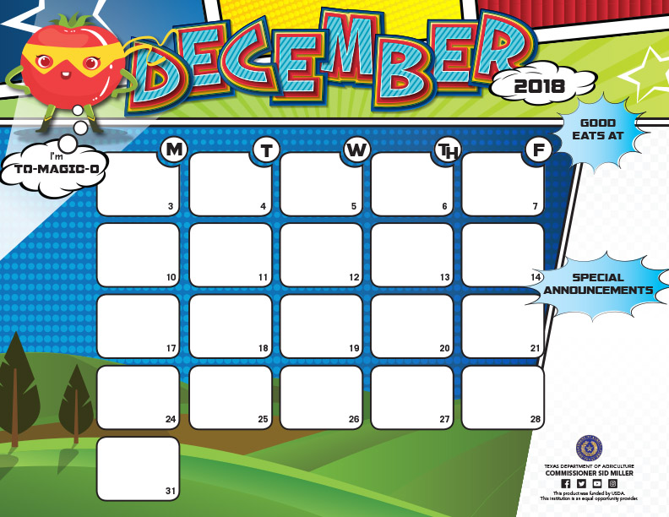

|  |
| --- |
| **Grilled Cheese Sandwich** |
| **Assorted Cereals** |
| **Buttered Toast** |
| **Sliced Pears** |
| **Assorted Juice** |
| **Grape Jelly** |

|  |
| --- |
| ***Breakfast Slider*** |
| **w/Jelly** |
| **Assorted Cereals** |
| **Pop tart** |
| ***Orange Wedges*** |
| ***Assorted Juice*** |

|  |
| --- |
|  |
| **Breakfast Pizza** |
| **Assorted Cereals** |
| **Yogurt** |
| **Applesauce** |
| ***Assorted Juice*** |

|  |
| --- |
| **Donut** |
| **Assorted Cereals** |
| **Cinnamon Toast** |
| **Cheese Stick** |
| **Applesauce Cup** |
| ***Assorted Juice*** |

|  |  |  |  |  |  |  |
| --- | --- | --- | --- | --- | --- | --- |
| |  | | --- | | ***Eggs, Cheese &*** | | **Ham Roll-Up** | | **Assorted Cereals** | | **Cheese Toast** | | ***Orange Wedges*** | | ***Assorted Juice*** | |
|  |
|  |
|  |
|  |

**JOAQUIN ISD RAM CAFÉ Breakfast Menu**

**Elementary $1.75 Junior High $1.75 High School $1.75 Adult $2.25**

|  |
| --- |
| **Cheese Chicken-n-** |
| **Biscuit** |
| **Assorted Cereals** |
| **Buttered Toast** |
| **Sliced Pears** |
| **Assorted Juice** |
| **Grape Jelly** |

|  |
| --- |
| ***Breakfast Buritto*** |
| **w/Jelly** |
| **Assorted Cereals** |
| **Pop tart** |
| ***Orange Wedges*** |
| ***Assorted Juice*** |

|  |
| --- |
| **Hot Pocket** |
| **Assorted Cereals** |
| **Cheese Toast** |
| ***Orange Wedges*** |
| ***Assorted Juice*** |

|  |
| --- |
| **Honey Bun** |
| **Assorted Cereals** |
| **Cinnamon Toast** |
| **Cheese Stick** |
| **Applesauce Cup** |
| ***Assorted Juice*** |

|  |
| --- |
| ***Pancake on Stick*** |
| **Syrup** |
| **Assorted Cereals** |
| **Yogurt** |
| **Applesauce** |
| ***Assorted Juice*** |

|  |  |  |  |  |  |  |
| --- | --- | --- | --- | --- | --- | --- |
| |  | | --- | | ***Cheese Quesadilla*** | | **w/Ham & salsa** | | **Assorted Cereals** | | **Cheese Toast** | | ***Orange Wedges*** | | ***Assorted Juice*** | |
|  |
|  |
|  |
|  |

|  |
| --- |
| **Grilled Cheese Sandwich** |
| |  | | --- | | **Assorted Cereals** | | **Buttered Toast** | | **Sliced Pears** | | **Assorted Juice** | | **Grape Jelly** | |

|  |
| --- |
| **Donut** |
| **Assorted Cereals** |
| **Cinnamon Toast** |
| **Cheese Stick** |
| **Applesauce Cup** |
| ***Assorted Juice*** |

|  |
| --- |
| ***Breakfast Slider*** |
| **w/Jelly** |
| **Assorted Cereals** |
| **Pop tart** |
| ***Orange Wedges*** |
| ***Assorted Juice*** |

|  |
| --- |
|  |
| **Breakfast Pizza** |
| **Assorted Cereals** |
| **Yogurt** |
| **Applesauce** |
| ***Assorted Juice*** |

Choice of milk everyday: White 1% Low Fat or Flavored Fat Free.

Menus are subject tochange without notice.







SCHOOL HOLIDAY

**CHRISTMAS DAY**



