Baseball Playoff Shirts

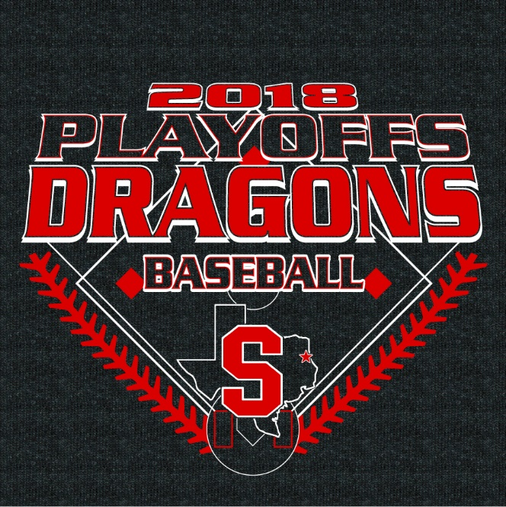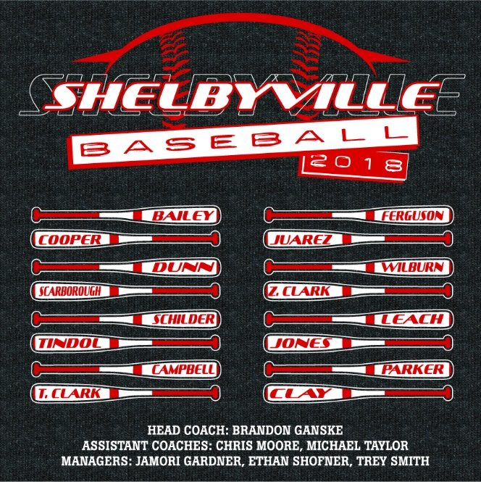
The Shirts will be Dark Grey Short Sleeves
The Price is $20
I must have orders by Friday, April 27th

Child’s Name________________________________________
Grade: _________ Teacher: ________________________
Sizes: YM YL AS AM AL XL XXL XXXL

Size | Quantity | Total Cost

Total number of shirts _________ Total amount owed ____________

