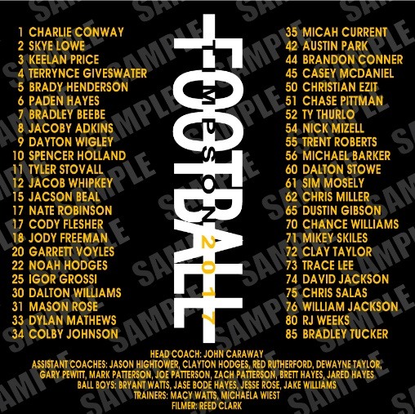
Timpson Football Playoff Shirts

Black shirt with gold lettering Our roster will be on this design.
 | Short Sleeve T-Shirt $15.00
 | Small | Medium | Large | XL | XXL | XXXL |  | 4XL | 5XL | Total # | Total $
Youth Quantity
Adult Quantity
 | Long Sleeve T-Shirt $20.00
 | Small | Medium | Large | XL | XXL | XXXL |  | 4XL | 5XL | Total # | Total $
Adult Quantity
 | Sweat Shirt $25.00
 | Small | Medium | Large | XL | XXL | XXXL |  | 4XL | 5XL | Total # | Total $
Adult Quantity
 | Hoodie $30.00 Front Screen Only
 | Small | Medium | Large | XL | XXL | XXXL |  | 4XL | 5XL | Total # | Total $
Adult Quantity

Name / Child’s Name ____________________________ Teacher _________________________
Phone ________________________ email _________________________________________
Total Shirts _______________ Total amount due__________________
Please return order form and money to Mrs. Therwhanger or Coach Therwhanger by November 8th. Checks payable to: Timpson ISD FOOTBALL

