Tenaha ISD Students of the Month
Each month teachers nominate students that exhibit outstanding qualities in and out of the classroom. Students that are featured each month display leadership skills, inspires others to excel and are committed to promoting a positive attitude towards achieving their goals.
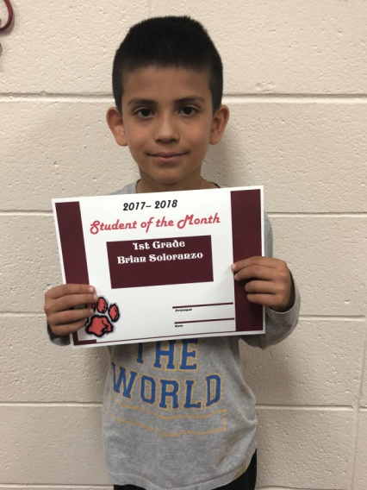
Bryan Soloranzo-1st Grade
Bryan is the son of Alicia and Rodolfo Solorzano. His favorite subjects are math and reading. Bryan is a leader among his classmates. He is friendly and always does his best. Bryan enjoys playing games.
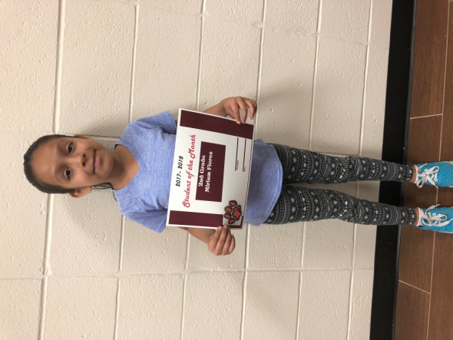
Miriam Flores-2nd Grade
Miriam is the daughter of Jose’ Flores and Alicia Espinoza. Her favorite subject is math and reading. Miriam is such a joy to work with. She is a hard worker and a good friend to her classmates.
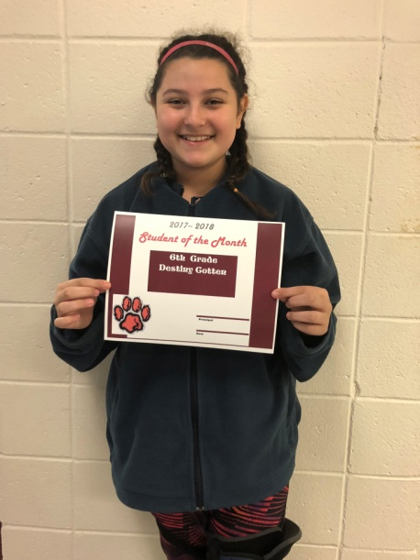
Destiny Cotten-6th Grade
Destiny is the daughter of Kendall and Misty Cotten. Her favorite subject is reading. Destiny always has her work turned in and ready to start a new task. She is very well behaved and respectful to her teachers and friends. In her spare time she likes to ride her horses, play basketball and softball.
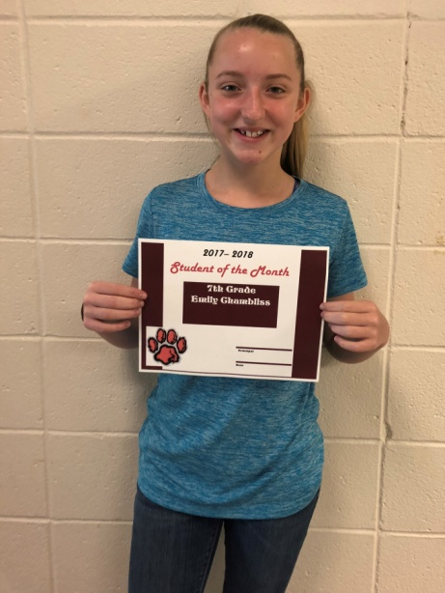
Emily Chambliss-7th Grade
Emily is the daughter of Kasey Hargrove and Robbie Chambliss. Her favorite subject is math. Emily is an outgoing student that excels in math and band. She loves to draw and hang out with her friends.
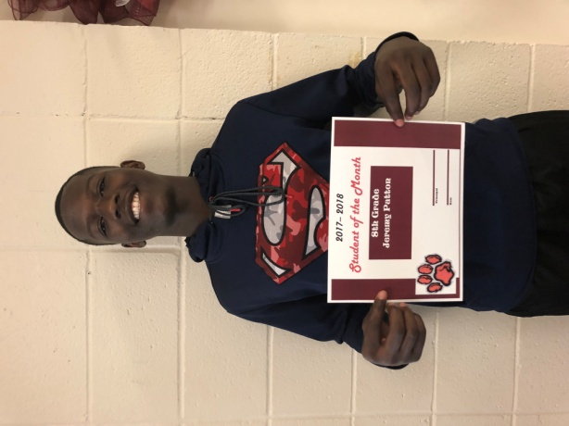
Jeremy Patton-8th Grade
Jeremy is the son of Kristy Norris. His favorite subject is math. Jeremy basketball football track. He loves to play sports and hopes to someday play college football or basketball. He spends his spare time studying and spends time with family and friends.
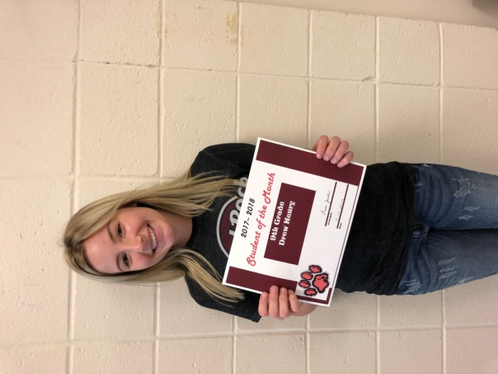
Drew Henry-9th Grade
Drew is the daughter of Shellie and Jamie Henry. Her favorite subject is math. She is actively involved in BETA, JCC, Robotics and Band. After high school her plans are to attend A & M University and become a surgical veterinarian.
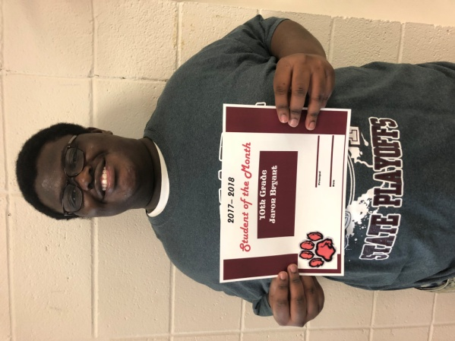
Jaron Bryant-10th Grade
Jaron is the son of Karen Roland. His favorite subject is Spanish 2 because he loves to speak Spanish. He is an active member of the band and water boy for football and basketball. After high school he plans to travel to Mexico because he could use his Spanish language there. He would also like to go to Florida and visit Disney World again.
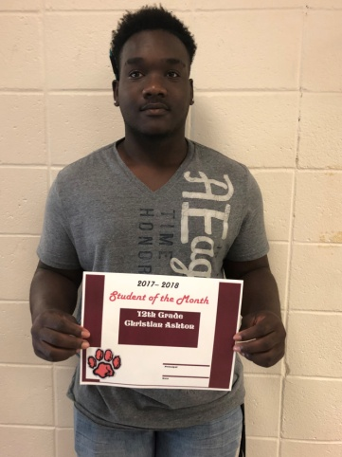
Christian Ashton-12th Grade
Christian is the son of Carla Ashton. He has participated in football, baseball, and track. He has earned multiple awards in football. His plans after graduation are to attend Panola Junior College and pursue a career in welding.

