September Students of the Month
Each month teachers nominate students that exhibit outstanding qualities in and out of the classroom. Students that are featured each month display leadership skills, inspires others to excel and are committed to promoting a positive attitude towards achieving their goals.
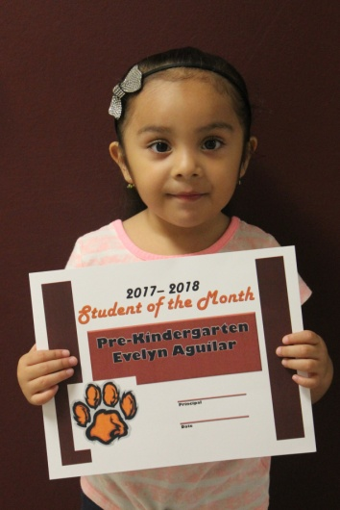
PK4-Evelyn Aguilar
Evelyn is the daughter of Brenda and Jose Aguilar. Her favorite subjects are her ABCs. She is always smiling and happy. She enjoys story time.
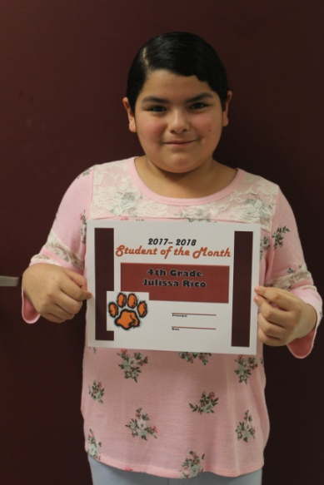
4th Grade-Julissa Rico
Julissa is the daughter of Arturo and Delfina Rico. Her favorite subject is PE. She is a very well-mannered student that works hard and makes good grades. Her main focus is school but she loves being in the band.
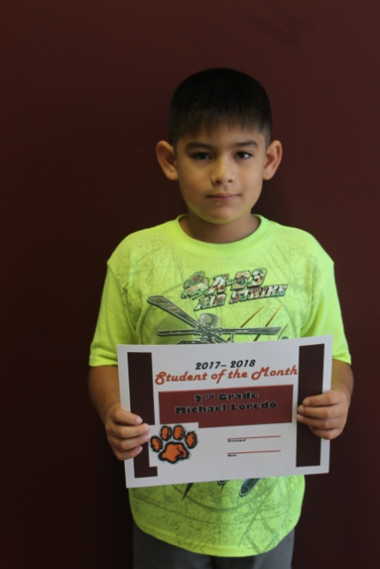
2nd Grade-Michael Loredo
Michael is the son of Patricia and Ramiro Loredo. His favorite subject is Science. Michael is a very hard worker. He gives his best on everything he does. He is a friend to all of his classmates and is always willing to help them at anytime. Michael loves building little boats.
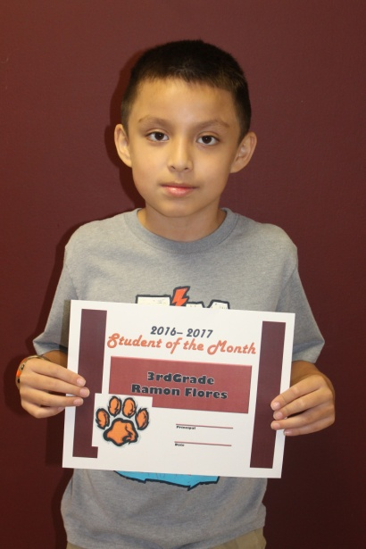
3rd Grade- Ramon Flores
Ramon is the son of Maria and Ramon Flores. He is a great runner and his favorite subject is reading. Ramon loves to play basketball with his brother. He also enjoys video games.

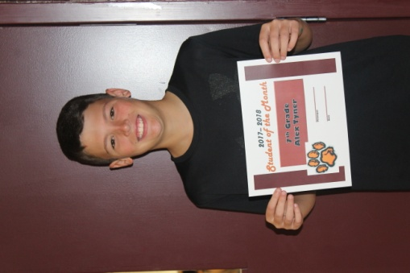
7th Grade- Alex Tyner
Alex is the son of Scott and Ali Tyner. His favorite subject is Math. He enjoys playing football, baseball and basketball. He also likes participating in robotics and BETA.
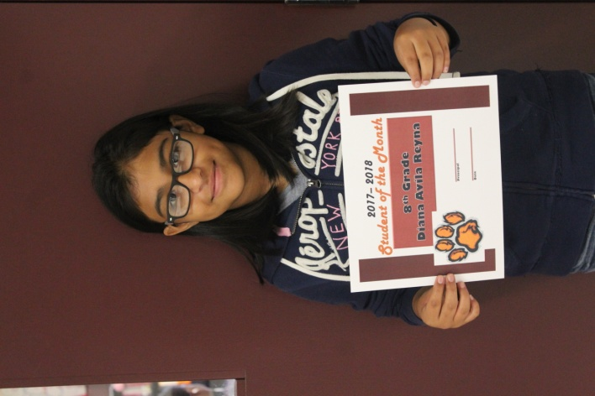
8th Grade- Diana Avila Reyna
Diana is the daughter of Silvia Avila and Jose Ochoa. Her favorite subject is Reading. She always tries her best to make good grades. She excels at Reading and Band.

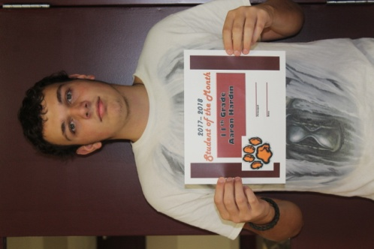
11th Grade -Aaron Hardin
Aaron is the son of Cynthia and John Hanway. Aaron’s favorite subject is Math. He enjoys listening to music, working out and watching movies. Aaron plans to attend college upon graduation.
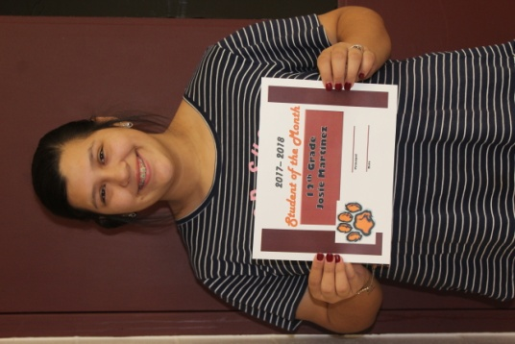
12th Grade-Josie Martinez
Josie is the daughter of Marcie Olalde. Her favorite subject is Reading. She enjoys listening to music, drawing and going to church. Her plans are to attend Panola Junior College after graduation.

