Tenaha ISD’s Students of the Month
Each month teachers nominate students that exhibit outstanding qualities in and out of the classroom. Students that are featured each month display leadership skills, inspires others to excel and are committed to promoting a positive attitude towards achieving their goals.
Tenaha ISD is excited to present the October Students of the Month.

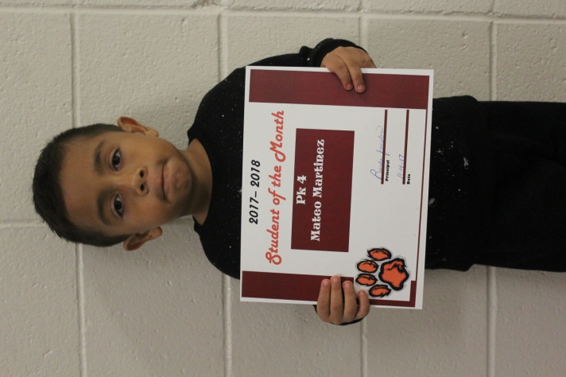
Mateo Martine
Mateo is a PK student. Mateo’s parents are Daniel Martinez and Lizbeth Garcia. Mateo enjoys circle time and playing with his friends. He is very helpful in class and has a great sense of humor. His favorite thing to do is play with animals.

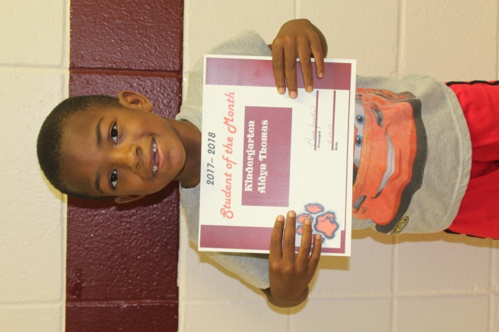
Aidyn Thomas
Aidyn is in Kindergarten. His parents are Kasey Carter Thomas and Freeman Thomas. He enjoys reading. Aidyn listens well in class and is always polite and kind to others. He is smart and learning fast! Aidyn’s favorite activity is to play Reading Eggs on the Ipad.
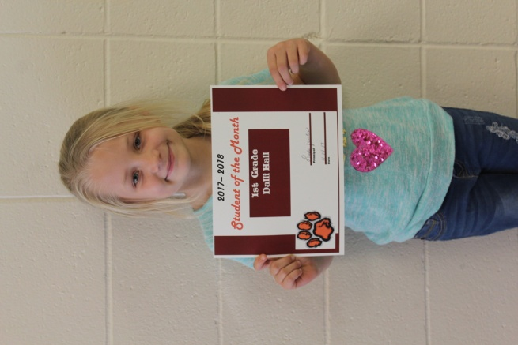
Dalli Hall
Dalli is in 1st grade. Dalli is the daughter of Daniel and Amanda Hall. Her favorite subjects are PE and writing. Dalli is a very outgoing student and a leader among her classmates. She loves to travel. Dalli enjoys riding horses, 4 wheeler riding and spending time with her family.
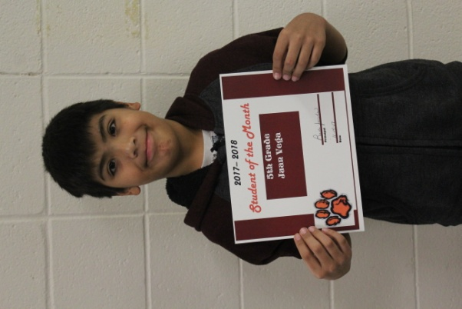
Juan Vega
Juan is in the 5th grade. His parents are Santo Sanchez and Alma Ruth Santana. His favorite subject is reading. Juan is a quiet, independent learner. He is a great teacher’s helper and a wonderful peer helper for his classmates. Juan enjoys playing games with his brothers and his little sister. He loves to travel to new places and see new things.

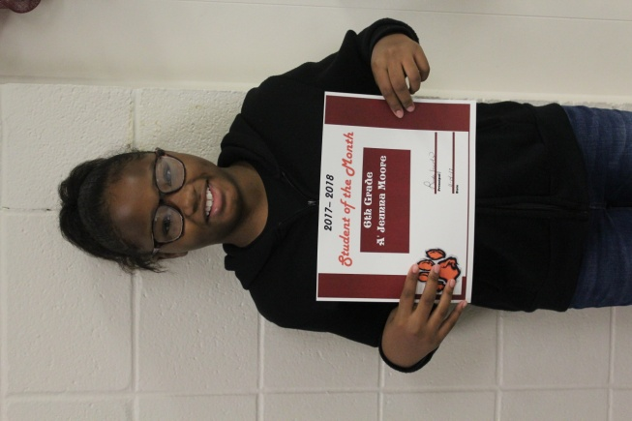
A’Jeunna Moore
A’Jeunna is a 6th grade student. Her parents are Justin Moore and Ashley Fredieu. Her favorite subject is math. A’Jeunna is a very hard worker. She is very quiet, never complains and is very respectful to everyone she comes in contact with. She is an all around great student. She enjoys playing with her friends and family. She attends Pleasant Hill Baptist Church.
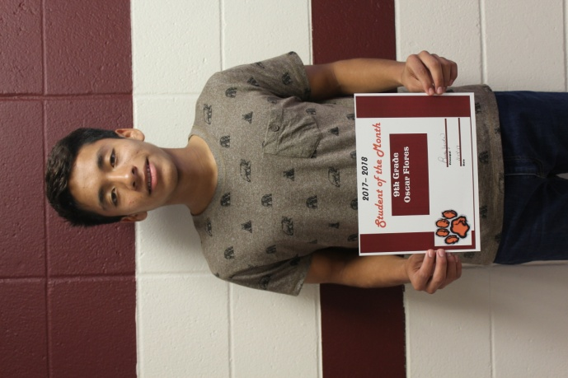
Oscar Flores
Oscar is in the 9th grade. Oscar’s parents are Roberto and Ana Flores. His favorite subject is Algebra. He enjoys participating on the Cross Country team and Soccer. His plans after graduation include attending a college to become a software engineer.
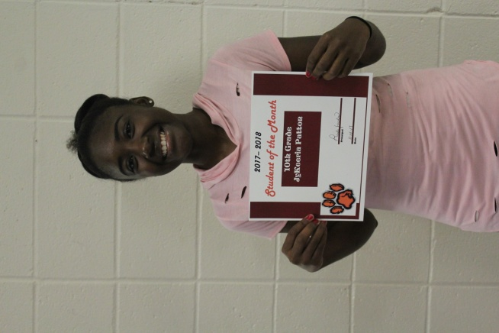
Jykeeria Patton
Jykeeria is in the 10th grade. Her parent is Kristy Norris. Her favorite subject is Geometry. Jykeeria is an active member of the Junior Chamber of Commerce. She is a dedicated scholar and plans to attend college after graduating high school to become a Physical Therapist.

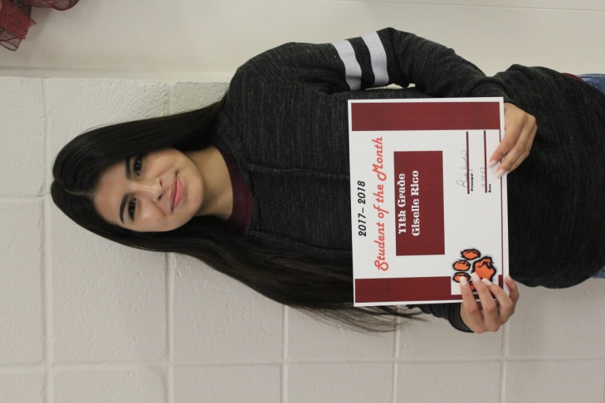
Giselle Rico
Giselle is in the 11th grade. Her parents are Arturo and Delfina Rico. Her favorite subject is math. Giselle is a very kind and thoughtful student. Giselle is involved in FFA, BETA, Soccer and JCCs. Giselle plans to attend college after graduation.

