Shelbyville ISD  School Menu  Middle School  High School  936-598-7323 |  | 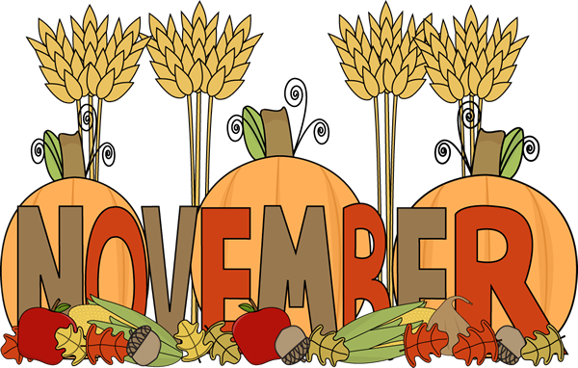 2017
www.shelbyville.k12.tx.us |  | Monday | Tuesday | Wednesday | Thursday | Friday
 |  |  |  | 1 Pancakes | 2 Sausage Biscuit | 3 Honey Bun
Breakfast Served Daily  Choice of breakfast entrée or assorted cereal, juice or fruit, 1% milk or fat-free chocolate milk |  |  |  | General TSO’S Chicken  Oriental Veggies  Baked Beans  Fruit & Fortune Cookie  Milk Choice | Salisbury Steak  Rice & Gravy  Candied Yams  Fruit & Honey Roll  Milk Choice | Dragon Burgers  Baked Tots  Lettuce, Tom & Pickles  Carrot Sticks & ranch  Fruit/Milk Choice
 |  | 6 French Toast | 7 Kolaches | 8 Jamwiches | 9 Cinnamon Toast | 10 Donuts
Lunches  Choice of:  Line A  Traditional Menu |  | Chicken Nuggets  Mashed Potatoes  Broccoli Salad  Fruit Cup & Bread  Milk Choice | Taco Salad  Refried Beans  Mexi-Corn  Lettuce Cup & Salad  Fruit  Milk Choice | Beefy Casserole  Tomatoes & Okra  Peas & Carrots  Fruit Cup  Cornbread  Milk Choice | BBQ Mc Rib  Creamy Coleslaw  Baked Beans  Fruit  Honey Wheat Bread  Milk Choice | Beefy Nachos  Pinto Beans  Carrots Sticks & ranch  Fruit  Milk Choice
Line B |  | 13 Sausage Pancake | 14 Muffins | 15 Kolaches | 16 Jamwiches | 17 Donuts
Monday: Hamburger Basket or Hot Pocket  Tuesday: Pizza or Steak Sandwich or Spicy Chicken Sandwiches |  | Tater Tot Casserole  Turnip Greens  Pinto Beans  Fruit & Cornbread  Milk Choice | Chili Dogs  Baked Chips  Cucumber Coins /ranch  Steamed Carrots  Fruit/Milk Choice | Taco Salad  Refried Beans  Steamed Corn  Lettuce Cup & Salad  Fruit/Milk Choice | Turkey & Dressing  English Peas  Steamed Yams  Cranberry Sauce  Fruit/Turkey Cookie  Milk Choice | BBQ on Bun  Baked Beans  Broccoli & ranch  Pickles & Onions  Fruit Cup/Milk Choice
Wednesday: Cheeseburger Basket or |  | 20 | 21 | 22 | 23 | 24
Chicken Wraps or Cheese Sticks  Thursday: Pizza or Meatball Sub or Chicken Basket  Friday: BBQ Baked Potato or Taco Snacks |  | Thanksgiving Holidays | Thanksgiving Holidays | Thanksgiving Holidays | 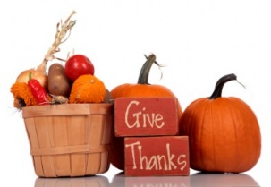 | Thanksgiving Holidays
 |  | 27 Jamwiches | 28 Breakfast Pizza | 29 Bacon Biscuit | 30 Pancakes
Daily: Chef Salad or Deli Sub  All lunches served with Fruit, Vegetables and Milk  This institution is an equal opportunity provider. |  | Steak Fingers  Mashed Potatoes  Green Beans  Fruit & Bread  Milk Choice | Chicken Fajitas  Refried Beans  Carrot Sticks & ranch  Fruit & Salsa  Milk Choice | Chili Cheese Pie  Steamed Corn  Pinto Beans  Fruit  Milk Choice | Homemade Soup  Grilled Cheese  Broccoli & ranch  Fruit & Crackers  Milk Choice | Menus are subject to change

