Shelbyville ISD  School Menu  Elementary |  | 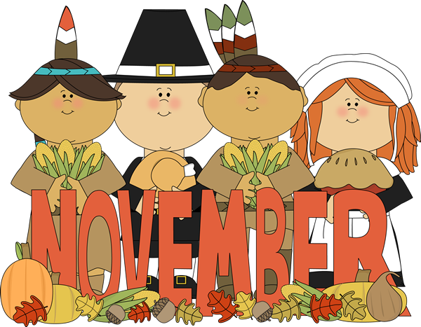2017
936-598-7363 |  | Monday | Tuesday | Wednesday | Thursday | Friday
www.shelbyville.k12.tx.us |  |  |  | 1 Pancakes | 2 Sausage Biscuits | 3 Honey Bun
Breakfast Served Daily |  |  |  | Corn Dog  Baked Beans  Mac & Cheese  Broccoli / ranch  Fruit / Milk Choice | Salisbury Steak  Rice & Gravy  Candied Yams  Fruit / Honey Wheat Roll  Milk Choice | Dragon Burgers  Baked Tots  Lettuce ,Tom,& Pickles  Carrot Sticks & ranch  Fruit /Milk Choice
 |  | 6 French Toast | 7 Kolaches | 8 Jamwiches | 9 Cinnamon Toast | 10 Donuts
Choice of breakfast entrée or assorted cereal, juice or fruit, 1% milk or fat-free chocolate milk |  | Chicken Nuggets  Mashed Potatoes  Broccoli Salad  Fruit Cup  Wheat Bread  Milk Choice | Taco Salad  Refried Beans  Mexi--Corn  Lettuce Cup & Salsa  Fruit & Fruit Roll-Up  Milk Choice | Beefy Casserole  Tomatoes & Okra  Peas & Carrots  Fruit Cup  Cornbread  Milk Choice | BBQ Mc Rib  Creamy Coleslaw  Baked Beans  Fruit  Wheat Bread  Milk Choice | Beefy Nachos  Pinto Beans  Carrot Sticks / ranch  Fruit  Milk Choice
 |  | 13 Sausage Pancake | 14 Muffins | 15 Kolaches | 16 Jamwiches | 17 Donuts
Lunches  Choice of:  Traditional Menu  Or |  | Tater Tot Casserole  Turnip Greens  Pinto Beans  Cornbread  Fruit Milk Choice | Chili Dogs  Baked Chips  Cucumber Coins /ranch  Steamed Carrots  Fruit  Milk Choice | Taco Salad  Refried Beans  Steamed Corn  Lettuce Cup & Salsa  Fruit & Milk Choice | Turkey & Dressing  English Peas  Steamed Yams  Cranberry Sauce  Fruit  Turkey Shaped Cookie  Bread & Milk Choice | BBQ on Bun  Baked Beans  Broccoli & ranch  Fruit  Milk Choice
Alternate Choice Daily |  | 20 | 21 | 22 | 23 | 24
Alternate Choices:  Pizza  Chef Salad  Stuffed Potato  Brown Bag Special |  | Thanksgiving Holidays | Thanksgiving Holidays | Thanksgiving Holidays |  | Thanksgiving Holidays
 |  | 27 Jamwiches | 28 Breakast Pizza | 29 Bacon & Biscuits | 30 Pancakes
All lunches served with Fruit, Vegetables and Milk  This institution is an equal opportunity provider. |  | Steak Fingers  Mashed Potatoes  Green Beans  Fruit & Bread  Milk Choice | Chicken Fajitas  Refries Beans  Carrots Sticks & ranch  Fruit & Salsa  Milk Choice | Chili Cheese Pie  Steamed Corn  Pinto Beans  Fruit  Milk Choice | Homemade Soup  Grilled Cheese  Broccoli & ranch  Fruit & Crackers  Milk Choice | Menus are subject to change

