Shelbyville ISD  School Menu  Middle School  High School  936-598-7323 |  | 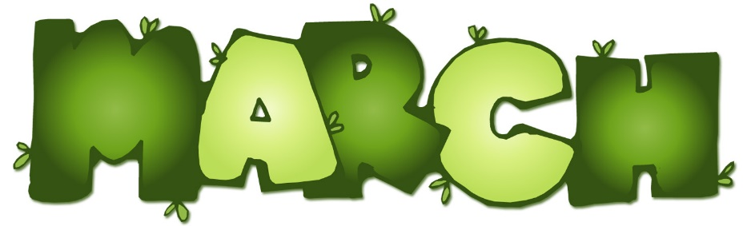 2018
www.shelbyville.k12.tx.us |  | Monday | Tuesday | Wednesday | Thursday | Friday
 |  |  |  |  | 1 Breakfast Pizza | 2 Donuts
Breakfast Served Daily  Choice of breakfast entrée or assorted cereal, juice or fruit, 1% milk or fat-free chocolate milk |  |  |  |  | Hamburger Casserole  Steamed Squash  Turnip Greens  Fruit / Cornbread  Milk Choice | Dragon Burgers  Baked Fries  Lettuce/Tomato/Pickles  Fruit  Milk Choice
 |  | 5 Sausage Pancake | 6 Cinnamon Toast | 7 Donuts | 8 Sausage Toast | 9 Muffins
Lunches  Choice of:  Line A  Traditional Menu |  | Steak Fingers  Mashed Potatoes  Broccoli Normandy  Fruit / Bread  Milk Choice | Chicken Fajitas  Pinto Beans  Spanish Rice  Fruit  Milk Choice | Chili Dogs  Baked Tots  Steamed Corn  Fruit  Milk Choice | Beef Tips  Gravy / Rice  Green Beans  Fruit / Wheat Roll  Milk Choice | BBQ on Bun  Chili Beans  Coleslaw  Fruit  Milk Choice
Line B |  | 12 | 13 | 14 | 15 | 16
Monday: Hamburger Basket or Hot Pocket

Tuesday: Pizza or Steak Sandwich or Spicy Chicken Sandwiches
Wednesday: Cheeseburger Basket or |  | 19 Kolaches | 20 Jamwiches | 21 Buttered Toast | 22 Pancakes | 23 Donuts
Chicken Wraps or Cheese Sticks  Thursday: Pizza or Meatball Sub or Chicken Basket  Friday: BBQ Baked Potato or Taco Snacks |  | Chicken Rings  Mashed Potatoes  Glazed Carrots  Fruit / Bread  Milk Choice | Taco Salad  Refried Beans  Steamed Corn  Fruit  Milk Choice | Chicken Spaghetti  Green Beans  Steamed Yams  Fruit  Wheat Roll  Milk Choice | BBQ Mc Rib  Scalloped Potatoes  Black-eyed Peas  Fruit  Bread  Milk Choice | Chili Cheese Pie  Ranch Style Beans  Broccoli / ranch  Fruit  Milk Choice
 |  | 26 Sausage Pancake | 27 Breakfast Pizza | 28 Waffles | 29 Honey Buns | 30
Daily: Chef Salad or Deli Sub  All lunches served with Fruit, Vegetables and Milk  This institution is an equal opportunity provider. |  | Steak Fingers  Mashed Potatoes  Sweet Peas  Fruit / Bread  Milk Choice | Orange Chicken  Baked Beans  Rice  Fruit / Fortune Cookie  Milk Choice | Beefy Nachos  Steamed Corn  Steamed Carrots  Fruit  Milk Choice | Chicken on Bun  Baked Chips  Lettuce , Pickles  Broccoli / ranch  Fruit  Milk Choice | Good Friday Holiday  Menus are subject to change

