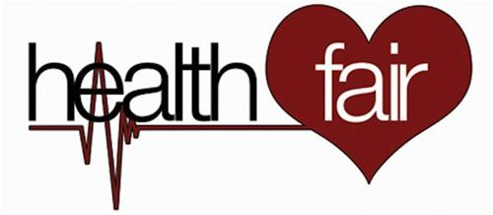
Shelbyville ISD

November 16, 2017
1:00 to 5:30 at the Shelbyville Cafetorium

Health screenings Safety Tips
Wellness Checks Educational Inf.
Flu Shots Nutritional Fact

Register to Win Great Prizes!

Services and Screenings Made Available by…
NMC Health Network, Panola Nursing College, Aurora Concepts, Texas Health Department of Carthage, Texas, AHEC East, HOPE Clinic, Cline Family Medical Holiday Nursing, Focus Care of Center, Pine Grove, DETCOG, Texas Department of Public Safety, Shelby County Advocacy Center, Performance Orthopedics, Loma Laird Cancer Center, Affinity Hospice, Shelby Co. Extension Office, Rodan +Fields Skin Care with Angie, Panola College OTA……

