CENTER HIGH SCHOOL
RED RIBBON WEEK
OCTOBER 23-27, 2017

CELEBRATE BEING DRUG FREE!!
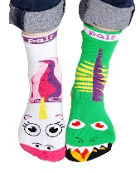
Monday, October 23rd –“Sock It To Drugs”
Wear your CRAZY SILLY OR MISMATCHED socks to school!

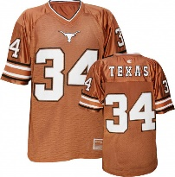
Tuesday, October 24th – “Team Up Against Drugs”
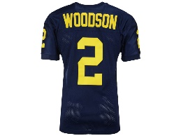
Wear your favorite Team shirt or Jersey to school!
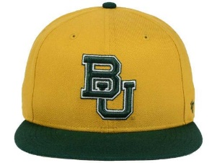

Wednesday, October 25th –“Put a Cap on Drugs”
Wear your favorite cap or hat to school!

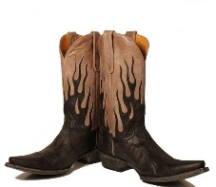
Thursday, October 26th –“Give Drugs the Boot”
Wear your favorite Boots to school!

Friday, October 27th –“Purple Pride Day”
Wear Purple & Gold! Center High School is
PROUD to stand up against Drugs!

