2018 Tenaha Elementary Awards
Multiple awards were handed out the last day of school for Tenaha Elementary. Students were recognized for their hard work through out the school year.
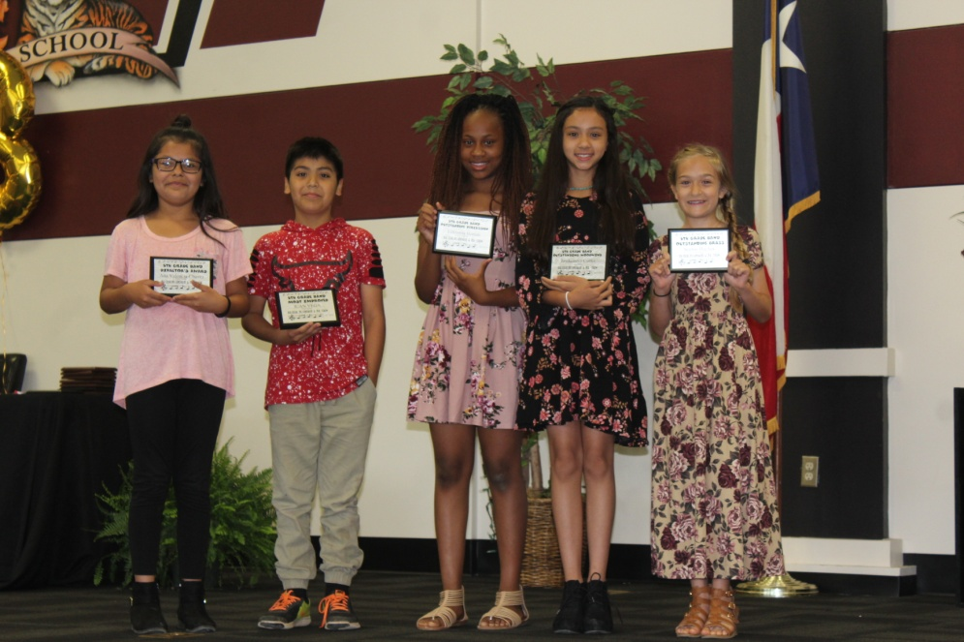
5th Grade Band Awards
Earning recognition in band were, left to right, Ana Valencia-Chevez Director’s Award, Juan Vega Most Improved, Lilliuanna Horton Outstanding Percussion, Jaydaleeya Curtis Outstanding Woodwin, and Sophie Hughes Outstanding Brass.
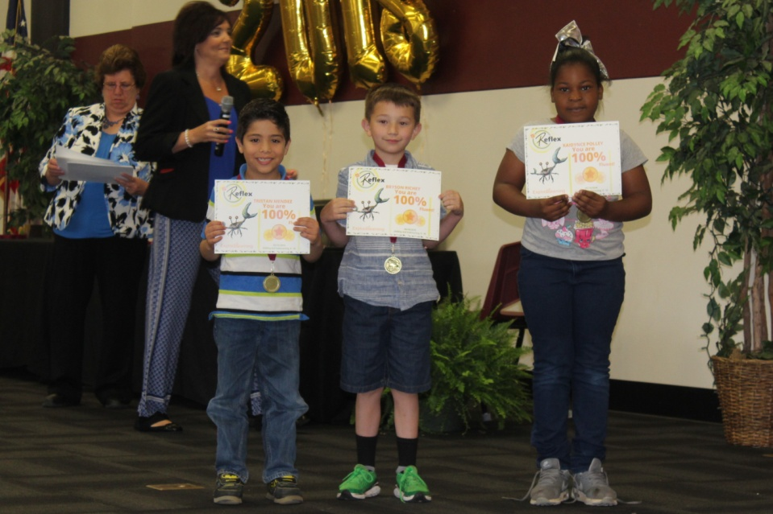
Reflex Math Awards 1st Grade
Pictured above: (left to right) Tristan Mendez, Bryson Richey, and Kaidynce Polley.
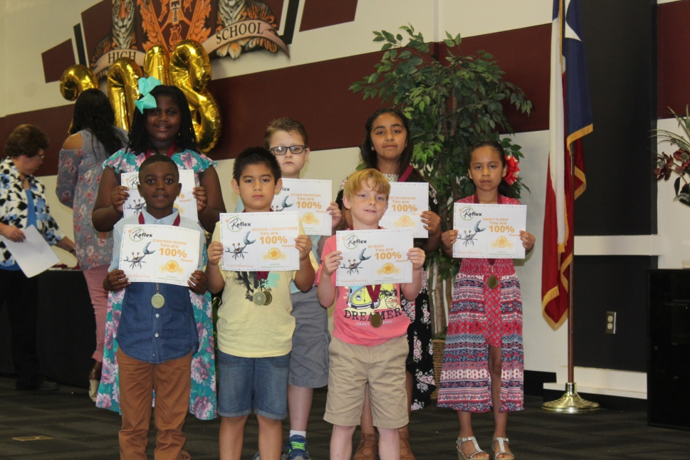
Reflex Math Awards 2nd Grade
Front row: (left to right) D’Kayden Moore, Michael Loredo-Torres, and Eli Bush. Back row: (left to right) Jaya Johnson, Bryce Fountain, Jocelyn Aquilar, and Nancy Flores.

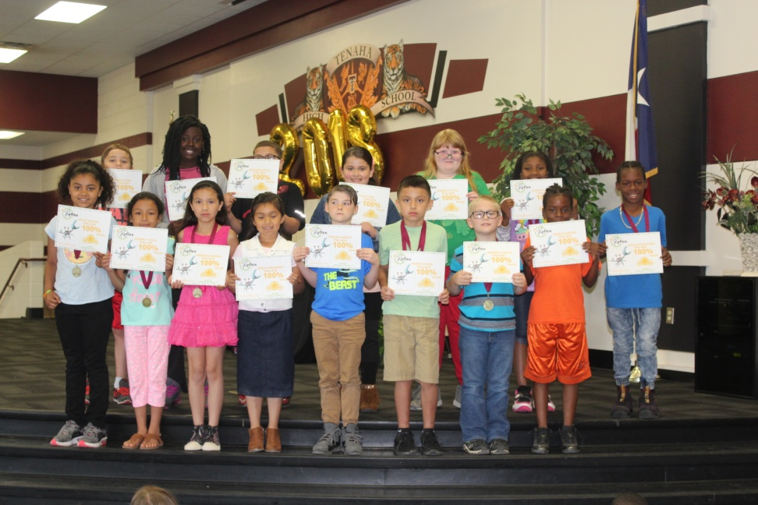
Reflex Math Awards 3rd Grade
Front row: (left to right) Anaya Walker, Kimberly Tovar, Verranza Mendez, Emily Hernandez, Stephen Garrett, Ramon Flores, Cameron Fleming, and J’Hase Scourton. Back row: (left to right) Connon Warr, Kianna Norris, Matthew Gatlin, Elsa Flores, Jasmine Clifton, Kendilyn Bell, and Malcolm Williams.
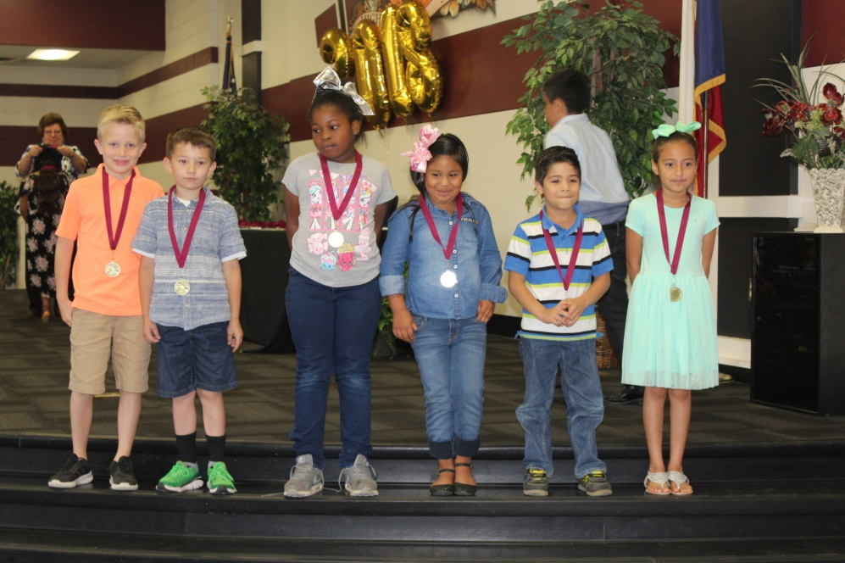
All A’s 1st Grade
Left to right: Aidan Tyner, Bryson Richey, Kaidynce Polley, Jaelyn Pecina, Tristan Mendez, and Vanidy Briseno.

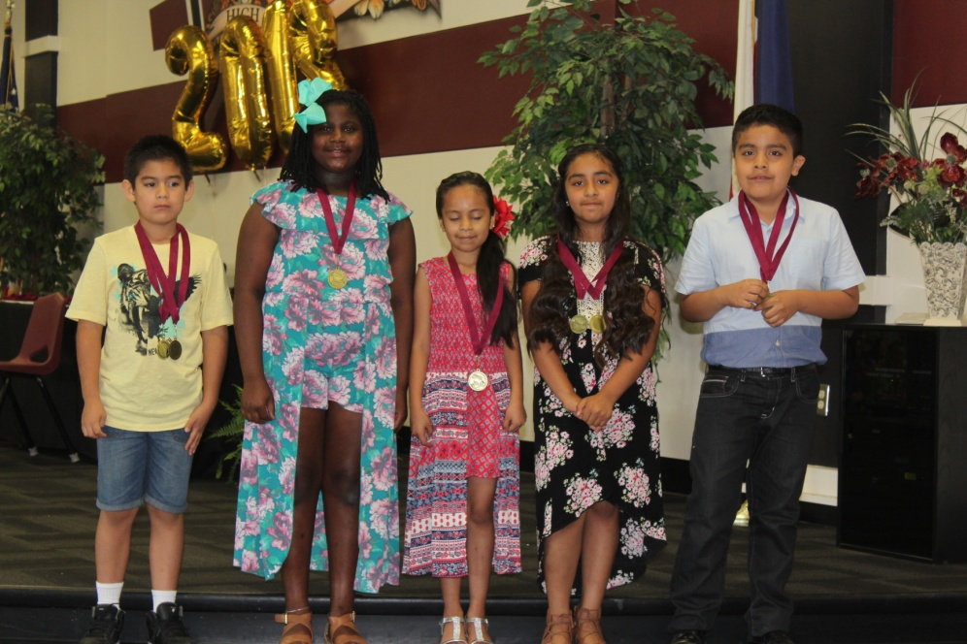
All A’s 2nd Grade
Left to right: Michael Loredo Torres, Jaya Johnson, Nancy Flores, Jocelyn Aquilar, and Jason Flores.
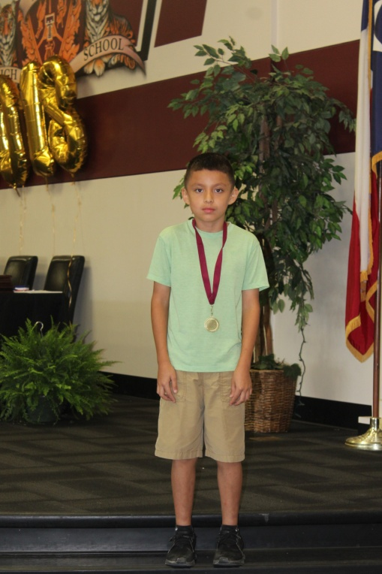
All A’s 3rd Grade
Ramon Flores
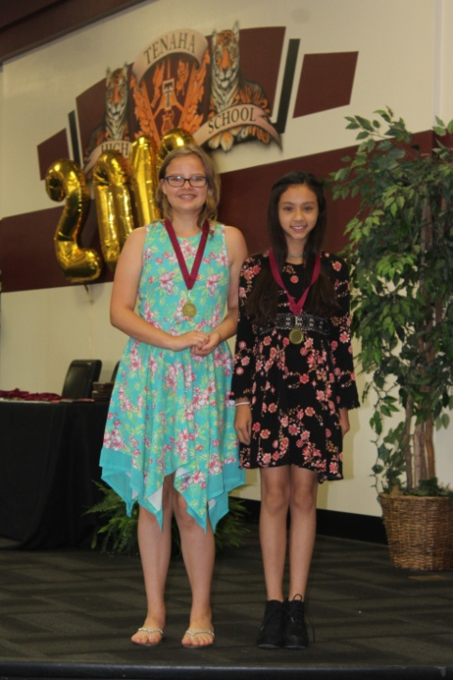
All A’s 5th Grade
Left to right: Briana Jackson and Jaydaleeya Curtis
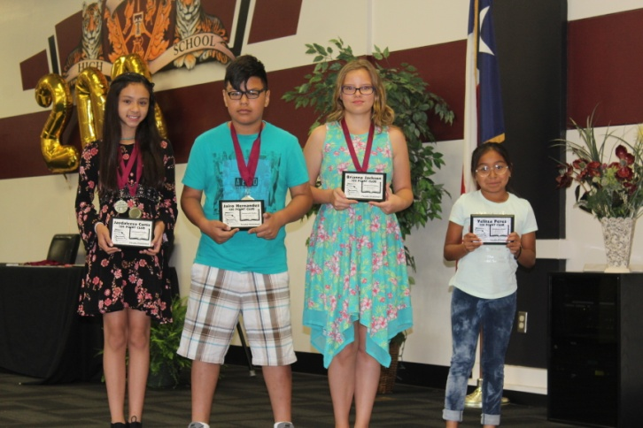
AR 100 Point Club
From left to right: Jaydaleeya Curtis, Jairo Hernandez, Briana Jackson, and Yelitza Perez.
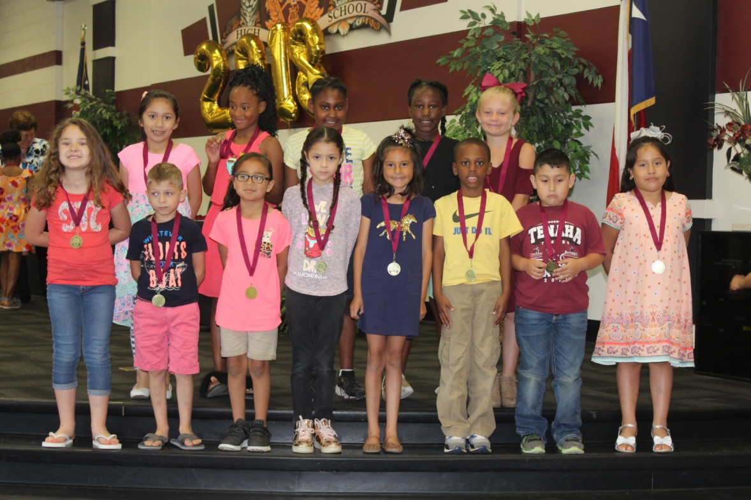
All A’s and B’s 1st Grade
Front row: (left to right) Farris Warr, Blayze Hurst, Isabella Perales, Keila Perez Lumbreras, Jocelyn Gonzalez, Ky’ron Giles, Julian Corpus, and Dayra Flores. Back row: (left to right) Gisel Vazquez, Kiauri Richardson, Te’Ajhza Landon, Ta’Laysia Kelly, and Dalli Hall.

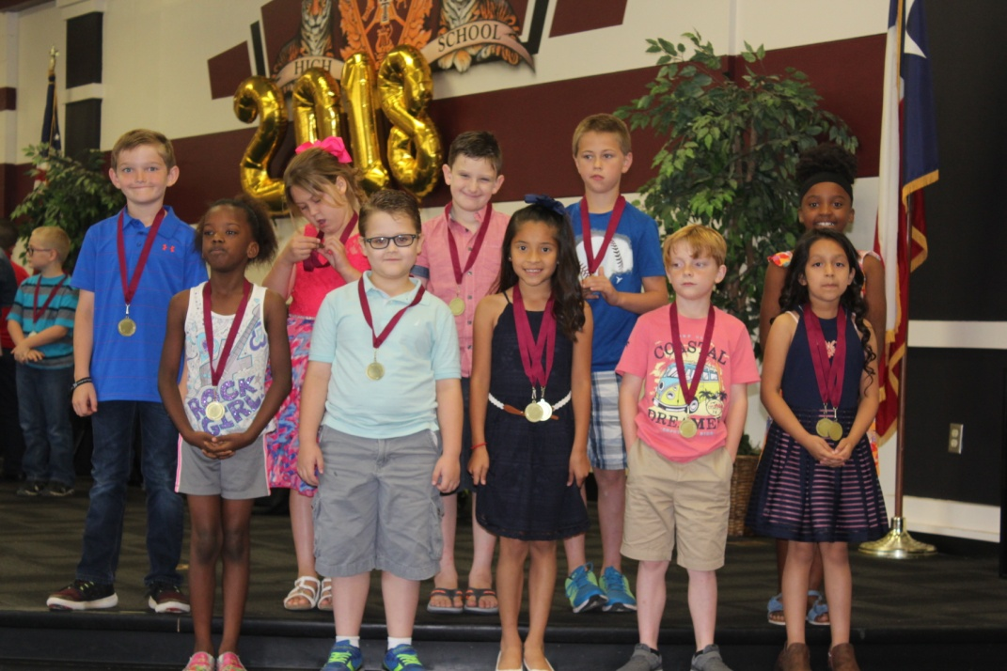
All A’s and B’s 2nd Grade
Front row: (left to right) Fallon Thomas, Julian Fountain, Evelyn Galvan, Eli Bush, and Miriam Flores Espinoza. Back row: (left to right) Cameron Shofner, Sophia Watson, Carter Duncan, and Christian Lewis, and Mar’Keriyah Davis.
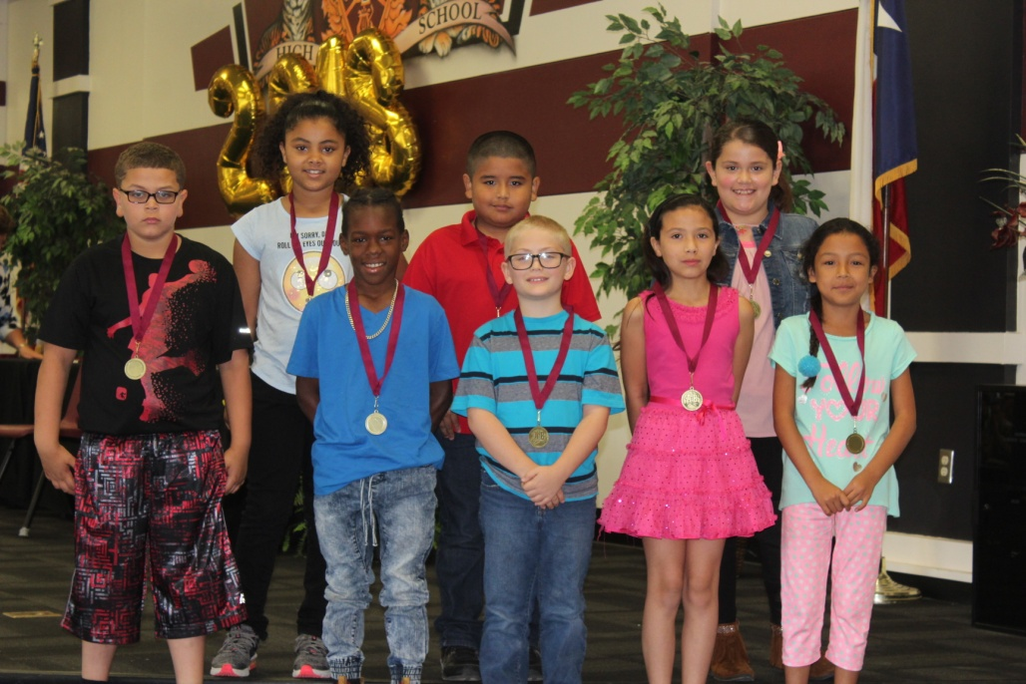
All A’s and B’s 3rd Grade
Front row: (left to right) Matthew Gatlin, Malcom Williams, Cameron Fleming, Verranza Mendez, and Kimberly Tovar. Back row: (left to right) Anaya Walker, Jonathan Ramirez, and Elsa Flores.
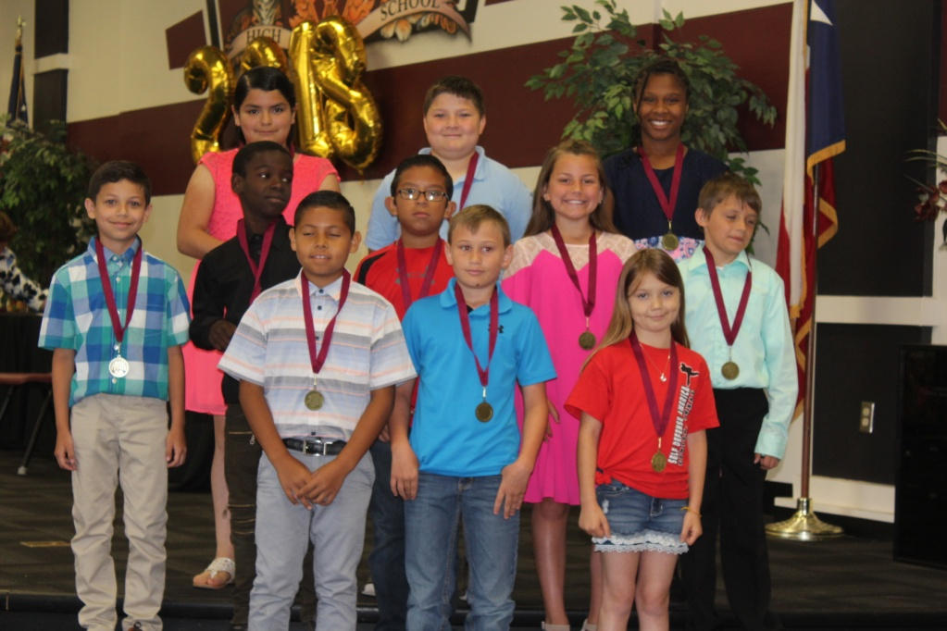
All A’s and B’s 4th Grade
Front row: (left to right) Jesus Rico, Cade Sims, and Brooklyn Swann. Middle row: (left to right) Arron Plata, Decaden Cooks, Eddie Berona, Macee Henry, and Kaleb Wagstaff. Back row: (left to right) Alondra Gonzales, Keegan Cotten, and Ty’Kyriana Barnes.

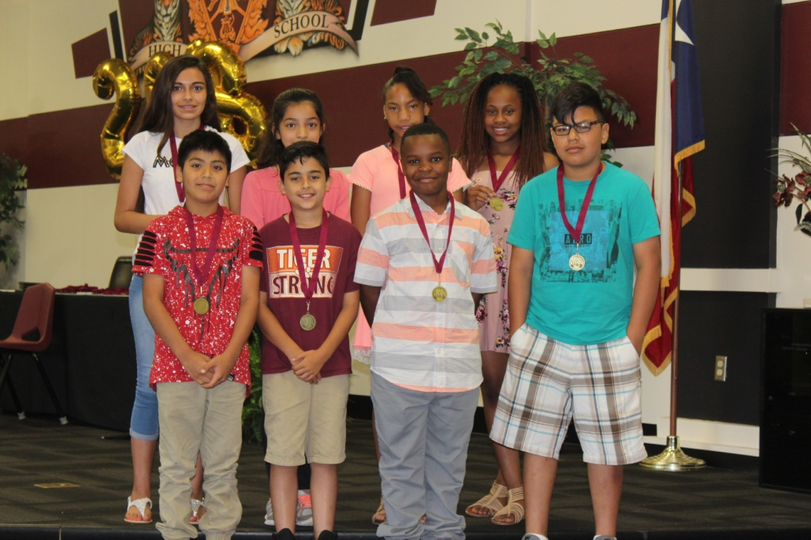
All A’s and B’s 5th Grade
Front row: (left to right) Juan Vega, Jayden Beatriz, Christopher Suell, and Jiaro Hernandez. Back row: (left to right) Chezni Dominguez, Yuliana Perez, Tatyana Adams, and Lilliuanna Horton.
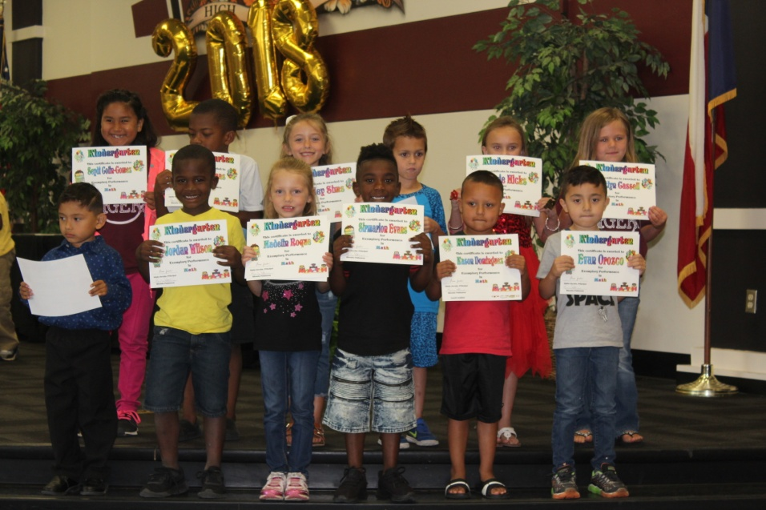
Math Stars-Kindergarten
Front row: (left to right) Jael Sandaval , Jordan Wilson, Madelin Rogue, Sirmarion Evans, Kason Dominguez, and Evan Orozco. Back row: (left to right) Seydi Colin-Gomez, Aidyn Thomas, Hadley Sims, Korbyn Fontenot, Gracie Hicks, and Caitlyn Cassell.

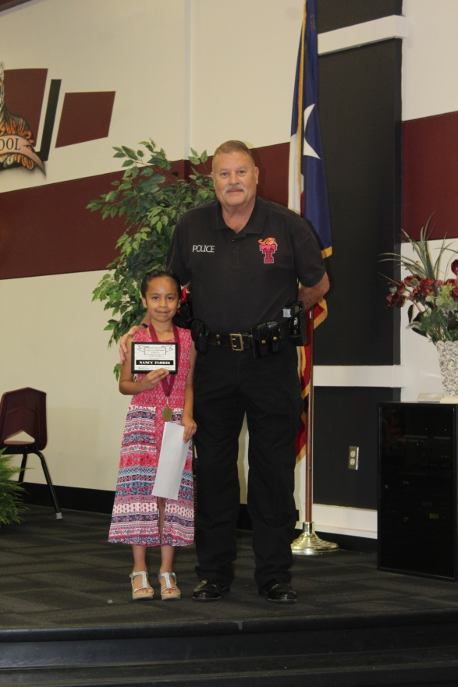
The Citizenship Award was presented by David Jeter to Nancy Flores.

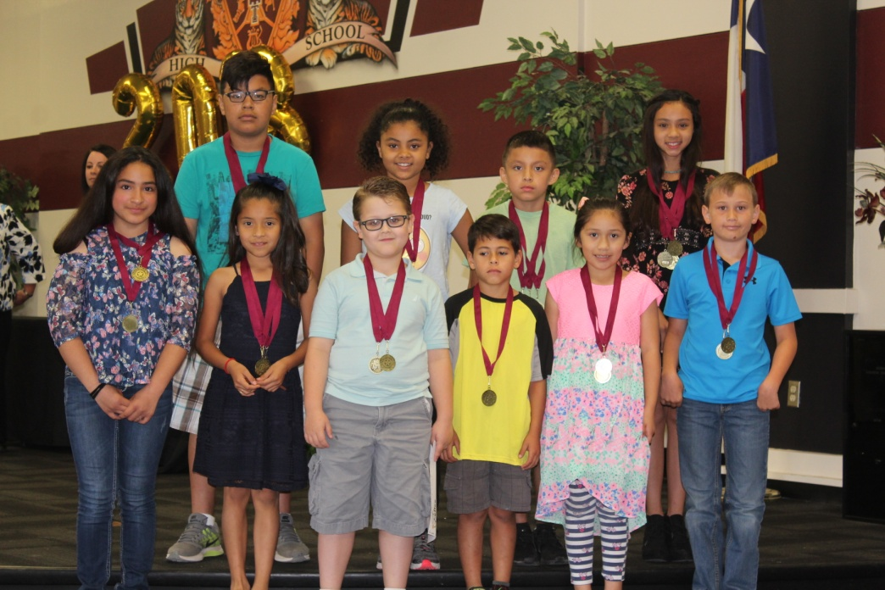
Math Stars 1st-5th Grade
Front row: (left to right) Alandra Gonzales, Evelyn Galvan, Bryce Fountain, Owen Tercero, Gisel Vasquez, and Cade Sims. Back row: (left to right) Jairo Hernandez, Anaya Walker, Raymon Flores, and Jaydaleeya Curtis.

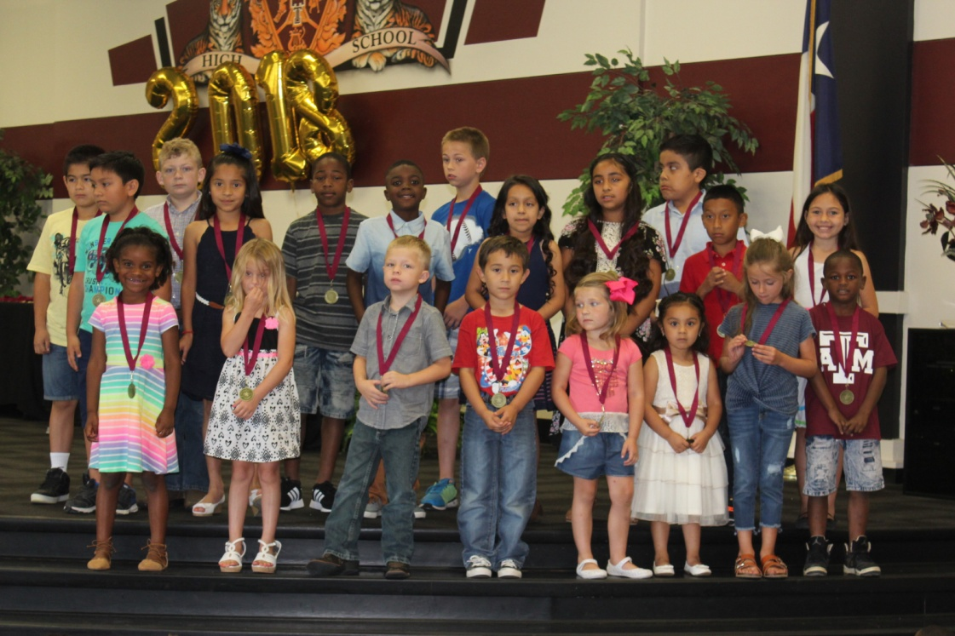
Perfect Attendance
Front row: (left to right) Kendyll Cato, ILove George, Jace Estes, Moses Caballero, Kenzley Hurst, Evelyn Aguilar, Hadley Sims, and John Jones. Back row: (left to right) Michael Laredo, David Laredo, Waylon George, Evelyn Galvan, Jakorrious Miles, D’Kayden Moore, Christian Lewis, Miriam Flores, Joselynn Aguilar, Jason Flores, Damian Escalante, and Julia Beatrice.

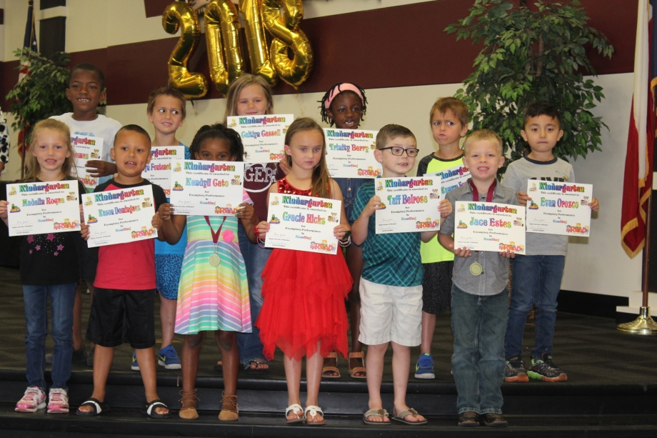
Reading Stars-Kindergarten
Front row: (left to right) Madelin Rogue, Kason Dominguez, Kendyll Cato, Gracie Hicks, Tuff Belrose, and Jace Estes. Back row: (left to right) Aidyn Thomas, Korbyn Fontenot, Caitlyn Cassell, Trinity Berry, Kamryn Fontenot, and Evan Orozco.

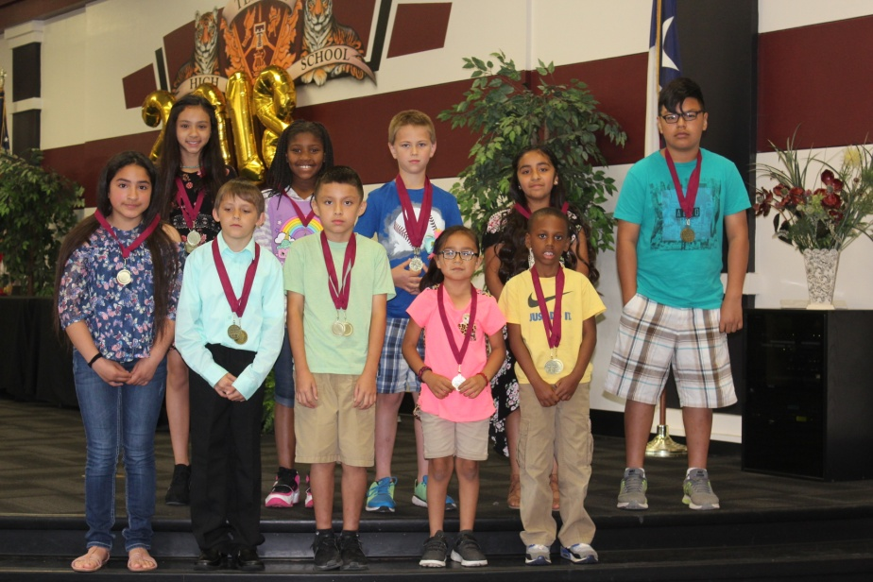
Reading Stars 1st Grade-5th Grade
Front row: (left to right) Alondra Gonzales, Kaleb Wagstaff, Ramon Flores, Isabella Perales, and Kyron Giles. Back row: (left to right) Jaydaleeya Curtis, Kendilyn Bell, Christian Lewis, Gisel Vazquez, and Jairo Hernandez.

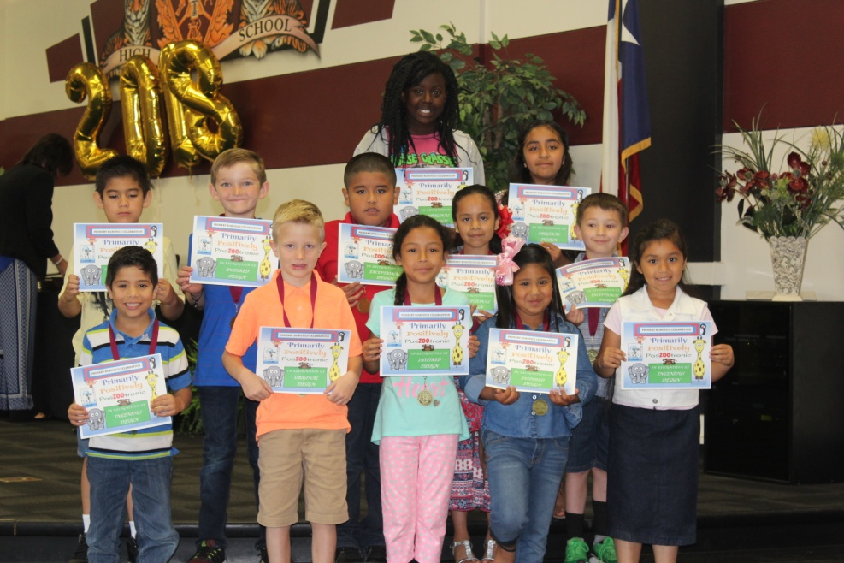
Robotics 1st Grade-3rd Grade
Front row: (left to right) Tristan Mendez, Aidan Tyner, Kimberly Tovar, Jaelyn Pecina, and Emely Hernandez. Middle Row: (left to right) Michael Santana, Cameron Shofner, Jonathan Ramirez, Nancy Flores, and Bryson Richey. Back row: (left to right) Kianna Norris, and Jocelyn Aguilar.

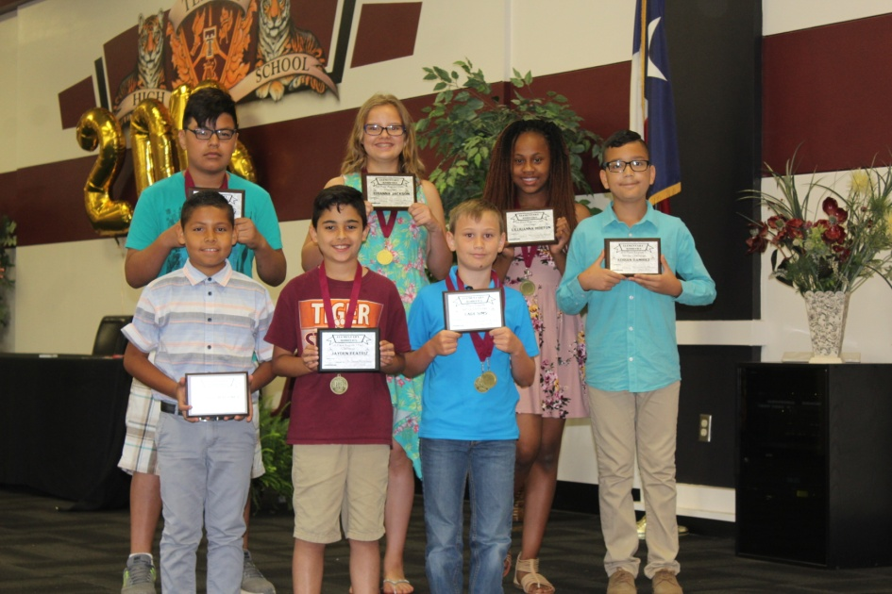
Robotics 4th and 5th Grade
Front row: (left to right) Ezequel Martinez, Jayden Beatriz, Cade Sims, and Adrian Ramirez. Back row: (left to right) Jairo Hernandez, Brianna Jackson, and Lilliuanna Horton.

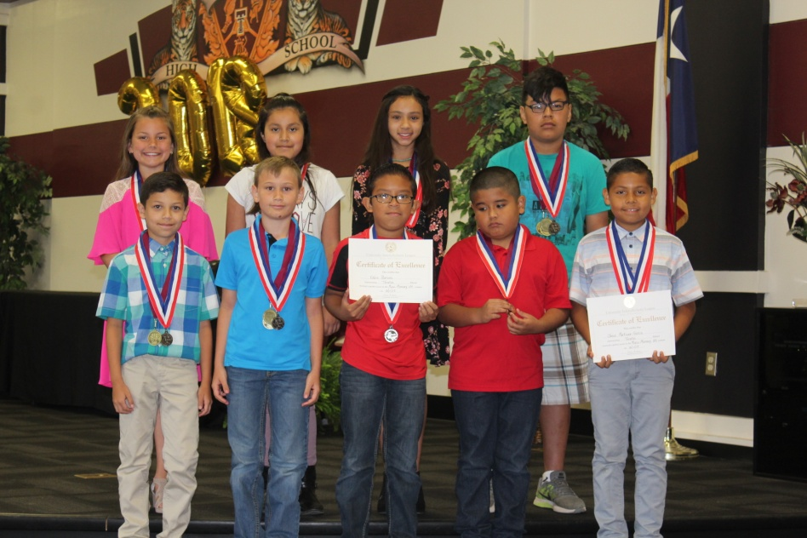
UIL Awards
Front row: (left to right) Aaron Plata, Cade Sims, Eddie Barona, Jonathan Ramirez, and Ezequel Martinez. Back row: (left to right) Macee Henry, Diana Flores, Jaydaleeya Curtis, and Jairo Hernandez.

