Shelbyville ISD  School Menu  Middle School  High School  936-598-7323 |  | 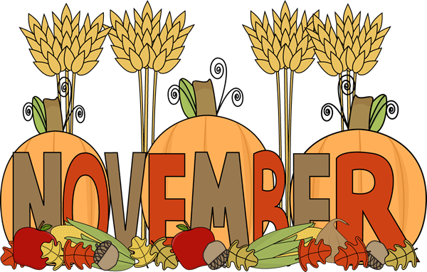 2018
www.shelbyville.k12.tx.us |  | Monday | Tuesday | Wednesday | Thursday | Friday
 |  |  |  |  | 1 Sausage / Toast | 2 Donuts
Breakfast Served Daily  Choice of breakfast entrée or assorted cereal, juice or fruit, 1% milk or fat-free chocolate milk |  | Menus are subject to change |  |  | BBQ Mc Rib  Baked Beans  Creamy Coleslaw  Fruit / Bread  Milk Choice | Chicken on Bun  Baked Chips  Lettuce ,Pickles  Carrots / ranch  Fruit  Milk Choice
 |  | 5 Sausage Pancake | 6 Cinnamon Toast | 7 Muffins | 8 Pancakes | 9 Honey Buns
Lunches  Choice of:  Line A  Traditional Menu |  | Chicken Nuggets  Mashed Potatoes  Green Beans  Fruit / Bread  Milk Choice | Orange Chicken  Rice  Baked Beans  Fruit /Fortune cookie  Milk Choice | Beefy Soup  Grilled Cheese Sandwich  Broccoli / ranch  Fruit / Crackers  Milk Choice | Taco Salad  Refried Beans  Steamed Corn  Fruit  Milk Choice | Steak Sandwich  Celery Sticks/ peanut butter  Lettuce/tomato cups  Fruit  Milk Choice
Line B |  | 12 Kolaches | 13 Brk. Pizza | 14 Pancakes | 15 Buttered Toast | 16 Muffins
Monday: Hamburger Basket or Hot Pocket  Tuesday: Pizza or Steak Sandwich or Spicy Chicken Sandwiches |  | Chicken Rings  Mashed Potatoes  Green Beans  Fruit  Bread  Milk Choice | Hot Ham Sandwiches  Baked Chips  Pickle Spears  Carrot Sticks / ranch  Fruit  Milk Choice | Turkey & Dressing  English Peas  Candied Yams  Fruit / Cranberry sauce  Honey Wheat Rolls  Milk Choice | Orange Chicken  Rice  Mixed Veggies  Fruit / Fortune Cookie  Milk Choice | BBQ on Bun  Baked Beans  Creamy Coleslaw  Fruit  Milk Choice
Wednesday: Cheeseburger Basket or |  | 19 | 20 | 21 | 22 | 23
Chicken Wraps or Cheese Sticks  Thursday: Pizza or Meatball Sub or Chicken Basket  Friday: BBQ Baked Potato or Taco Snacks |  | Thanksgiving Holidays | Thanksgiving Holidays | Thanksgiving Holidays | 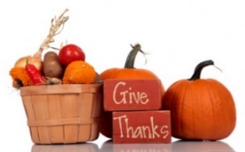 | Thanksgiving Holidays
 |  | 26 Sausage Pancake | 27 Frittata | 28 Cinnamon Toast | 29 Muffins | 30 Donuts
Daily: Chef Salad or Deli Sub  All lunches served with Fruit, Vegetables and Milk  This institution is an equal opportunity provider. |  | Steak Fingers  Mashed Potatoes  Green Beans  Fruit / Bread  Milk Choice | Salisbury Steak  Rice & Gravy  Steamed Broccoli  Honey Wheat Rolls  Fruit  Milk Choice | Chicken & Dumplings  Black-eyed Peas  Steamed Corn  Fruit  Cornbread  Milk Choice | BBQ on Bun  Baked Beans  Creamy Coleslaw  Fruit  Milk Choice | Beefy Nachos  Pinto Beans  Carrot Sticks  Fruit  Milk Choice

