Shelbyville ISD  School Menu  Elementary |  | 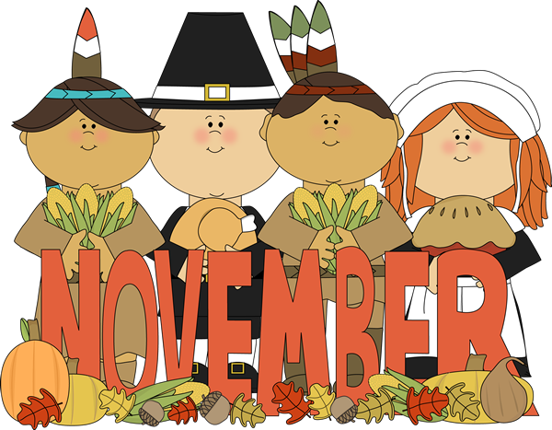2018
936-598-7363 |  | Monday | Tuesday | Wednesday | Thursday | Friday
www.shelbyville.k12.tx.us |  |  |  |  | 1 Sausage / Toast | 2 Donuts
Breakfast Served Daily |  | Menus are subject to change |  |  | BBQ Mc Rib  Baked Beans  Creamy Coleslaw  Fruit / Bread  Milk Choice | Chicken on Bun  Baked Chips  Lettuce ,Pickles  Carrots / ranch  Fruit  Milk Choice
 |  | 5 Sausage Pancake | 6 Cinnamon Toast | 7 Muffins | 8 Pancakes | 9 Honey Buns
Choice of breakfast entrée or assorted cereal, juice or fruit, 1% milk or fat-free chocolate milk |  | Chicken Nuggets  Mashed Potatoes  Green Beans  Fruit / Bread  Milk Choice | Corn Dogs  Baked Beans  Mac & Cheese  Fruit  Milk Choice | Beefy Soup  Grilled Cheese Sandwich  Broccoli / ranch  Fruit / Crackers  Milk Choice | Taco Salad  Refried Beans  Steamed Corn  Fruit  Milk Choice | Steak Sandwich  Celery Sticks/ peanut butter  Lettuce/tomato cups  Fruit  Milk Choice
 |  | 12 Kolaches | 13 Brk. Pizza | 14 Pancakes | 15 Buttered Toast | 16 Muffins
Lunches  Choice of:  Traditional Menu  Or |  | Chicken Rings  Mashed Potatoes  Green Beans  Fruit  Bread  Milk Choice | Hot Ham Sandwiches  Baked Chips  Pickle Spears  Carrot Sticks / ranch  Fruit  Milk Choice | Turkey & Dressing  English Peas  Candied Yams  Fruit / Cranberry sauce  Honey Wheat Rolls  Milk Choice | Pizza  Broccoli / ranch  Mixed Veggies  Fruit  Milk Choice | BBQ on Bun  Baked Beans  Creamy Coleslaw  Fruit  Milk Choice
Alternate Choice Daily |  | 19 | 20 | 21 | 22 | 23
Alternate Choices:  Pizza  Chef Salad  Stuffed Potato  Brown Bag Special |  | Thanksgiving Holidays | Thanksgiving Holidays | Thanksgiving Holidays |  | Thanksgiving Holidays
 |  | 26 Sausage Pancake | 27 Frittata | 28 Cinnamon Toast | 29 Muffins | 30 Donuts
All lunches served with Fruit, Vegetables and Milk  This institution is an equal opportunity provider. |  | Steak Fingers  Mashed Potatoes  Green Beans  Fruit / Bread  Milk Choice | Salisbury Steak  Rice & Gravy  Steamed Broccoli  Honey Wheat Rolls  Fruit  Milk Choice | Chicken & Dumplings  Black-eyed Peas  Steamed Corn  Fruit  Cornbread  Milk Choice | BBQ on Bun  Baked Beans  Creamy Coleslaw  Fruit  Milk Choice | Beefy Nachos  Pinto Beans  Carrot Sticks  Fruit  Milk Choice

